**VIVEKANAND EDUCATION SOCIETY’S INSTITUTE OF TECHNOLOGY**

**An Autonomous Institute Affiliated to University of Mumbai**

**Department of Computer Engineering**



Project Report on

BitPredict: Predictive Analytics for Bitcoin

In partial fulfillment of the Fourth Year, Bachelor of Engineering (B.E.) Degree in Computer Engineering at the University of Mumbai

Academic Year 2023-24

**Submitted by**

Teesha Karotra D17B / 33

Tithi Jhamnani D17B / 31

Dimple Madhwani D17B / 38

Aditi Salvi D17B / 62

**Project Mentor**

Prof. Dr. Sujata Khedkar

(2023-24)

**VIVEKANAND EDUCATION SOCIETY’S INSTITUTE OF TECHNOLOGY**

**An Autonomous Institute Affiliated to University of Mumbai**

**Department of Computer Engineering**



**Certificate**

This is to certify that **Teesha Karotra (33), Tithi Jhamnani (31), Dimple Madhwani (38) and Aditi Salvi (62)** of Fourth Year Computer Engineering studying under the University of Mumbai have satisfactorily completed the project on “**BitPredict: Predictive Analytics of Bitcoin**” as a part of their coursework of PROJECT-II for Semester-VIII under the guidance of their mentor  **Dr. (Mrs.) Sujata Khedkar in the year 2023-2024.**

This project report entitled **BitPredict: Predictive Analytics of Bitcoin** by  ***Teesha Karotra, Tithi Jhamnani, Dimple Madhwani and Aditi Salvi*** is approved for the degree of **B.E. Computer Engineering.**

| Programme Outcomes | Grade |
| --- | --- |
| PO1,PO2,PO3,PO4,PO5,PO6,PO7, PO8, PO9, PO10, PO11, PO12  PSO1, PSO2 |  |

Date:

Project Guide:

------------------------------------------

**Project Report Approval**

**For**

**B. E (Computer Engineering)**

This project report entitled **BitPredict: Predictive Analytics of Bitcoin** by ***Teesha Karotra, Tithi Jhamnani, Dimple Madhwani and Aditi Salvi*** is approved for the degree of **B.E. Computer Engineering.**

Internal Examiner

---------------------------------------------

External Examiner

---------------------------------------------

Head of the Department

-----------------------------------------------

Principal

-----------------------------------------------

Date:

Place: Mumbai

**Declaration**

We declare that this written submission represents our ideas in our own words and where others' ideas or words have been included, we have adequately cited and referenced the original sources. We also declare that we have adhered to all principles of academic honesty and integrity and have not misrepresented or fabricated or falsified any idea/data/fact/source in our submission. We understand that any violation of the above will be cause for disciplinary action by the Institute and can also evoke penal action from the sources which have thus not been properly cited or from whom proper permission has not been taken when needed.

| -----------------------------------------  -----------------------------------------  Teesha Karotra (33) | -----------------------------------------  -----------------------------------------  Tithi Jhamnani (31) |
| --- | --- |
| -----------------------------------------  -----------------------------------------  Dimple Madhwani (38) | -----------------------------------------  -----------------------------------------  Aditi Salvi (62) |

Date:

**ACKNOWLEDGEMENT**

We are thankful to our college Vivekanand Education Society’s Institute of Technology for considering our project and extending help at all stages needed during our work of collecting information regarding the project.

It gives us immense pleasure to express our deep and sincere gratitude to Assistant Professor **Dr. (Mrs.) Sujata Khedkar** (Project Guide) for her kind help and valuable advice during the development of project synopsis and for her guidance and suggestions.

We are deeply indebted to Head of the Computer Department **Dr. (Mrs.) Nupur Giri** and our Principal **Dr. (Mrs.) J. M. Nair ,** for giving us this valuable opportunity to do this project.

We express our hearty thanks to them for their assistance without which it would have been difficult in finishing this project synopsis and project review successfully.

We convey our deep sense of gratitude to all teaching and non-teaching staff for their constant encouragement, support and selfless help throughout the project work. It is a great pleasure to acknowledge the help and suggestion, which we received from the Department of Computer Engineering.

We wish to express our profound thanks to all those who helped us in gathering information about the project. Our families too have provided moral support and encouragement several times.

**Computer Engineering Department**

**COURSE OUTCOMES FOR B.E PROJECT**

Learners will be to,

| **Course**  **Outcome** | **Description of the Course Outcome** |
| --- | --- |
| CO 1 | Able to apply the relevant engineering concepts, knowledge and skills towards the project. |
| CO2 | Able to identify, formulate and interpret the various relevant research papers and to determine the problem. |
| CO 3 | Able to apply the engineering concepts towards designing solutions for the problem. |
| CO 4 | Able to interpret the data and datasets to be utilized. |
| CO 5 | Able to create, select and apply appropriate technologies, techniques, resources and tools for the project. |
| CO 6 | Able to apply ethical, professional policies and principles towards societal, environmental, safety and cultural benefit. |
| CO7 | Able to function effectively as an individual, and as a member of a team, allocating roles with clear lines of responsibility and accountability. |
| CO8 | Able to write effective reports, design documents and make effective presentations. |
| CO 9 | Able to apply engineering and management principles to the project as a team member. |
| CO 10 | Able to apply the project domain knowledge to sharpen one’s competency. |
| CO 11 | Able to develop a professional, presentational, balanced and structured approach towards project development. |
| CO 12 | Able to adopt skills, languages, environment and platforms for creating innovative solutions for the project. |

**Index**

| Chapter No. | Title | Page No. |
| --- | --- | --- |
| **1** | **Introduction** | 11 |
| 1.1 | Introduction to the project | 11 |
| 1.2 | Motivation for the project | 11 |
| 1.3 | Problem Definition | 12 |
| 1.4 | Existing Systems | 12 |
| 1.5 | Lacuna of the Existing Systems | 13 |
| 1.6 | Relevance of the Project | 14 |
| **2** | **Literature Survey** | 15 |
| A | Brief overview of Literature Survey | 15 |
| 2.1 | Research Papers  a. Abstract of the research paper  b. Inference drawn from the paper | 15 |
| 2.2 | Inference Drawn | 33 |
| 2.3 | Comparison with the Existing Systems | 34 |
| **3.** | **Requirement Gathering for the proposed System** | 35 |
| 3.1 | Introduction to Requirement Gathering | 35 |
| 3.2 | Functional Requirements | 35 |
| 3.3 | Non-Functional Requirements | 36 |
| 3.4 | Hardware, Software, Technology and tools utilized | 36 |
| 3.5 | Constraints | 38 |
| **4.** | **Proposed Design** | 39 |
| 4.1 | Block diagram of the system | 39 |
| 4.2 | Modular design of the system | 40 |

| 4.3 | Detailed Design (Flowchart) | 41 |
| --- | --- | --- |
| 4.4 | Project Scheduling & Tracking using Timeline / Gantt Chart | 42 |
| **5.** | **Implementation of the Proposed System** | 43 |
| 5.1 | Methodology employed for development | 43 |
| 5.2 | Algorithms and flowcharts for the respective modules developed | 44 |
| 5.3 | Datasets source and utilization | 45 |
| **6.** | **Testing of the Proposed System** | 47 |
| 6.1 | Introduction to testing | 47 |
| 6.2 | Types of tests Considered | 48 |
| 6.3 | Various test case scenarios considered | 49 |
| 6.4 | Inference drawn from the test cases | 51 |
| **7.** | **Results and Discussions** | 53 |
| 7.1 | Screenshots of User Interface (UI) for the system | 53 |
| 7.2 | Performance Evaluation measures | 54 |
| 7.3 | Input Parameters / Features considered | 55 |
| 7.4 | . Graphical and statistical output | 56 |
| 7.5 | Comparison of results with existing systems | 65 |
| 7.6 | Inference drawn | 66 |
| **8.** | **Conclusion** | 67 |
| 8.1 | Comparison of algorithms used | 67 |
| 8.2 | Limitations | 68 |
| 8.3 | Conclusion | 68 |
| 8.4 | Future Scope | 69 |
|  | **References** | 70 |
| **1** | **Paper I** | 72 |
| a | Paper I | 72 |
| b | Plagiarism Report of Paper I | 78 |
| c | Project review sheet | 79 |

**List of Figures:**

| Fig no. | Heading | Page no. |
| --- | --- | --- |
| 4.1.1 | Block Diagram of the system | 39 |
| 4.2.1 | Modular Diagram of the system | 40 |
| 4.3.1 | DFD level 0 | 41 |
| 4.3.2 | DFD level 1 | 41 |
| 4.4.1 | Gantt Chart | 42 |
| 5.3.1 | Dataset used | 45 |
| 7.1.1 | The System UI showing the daily price prediction based on SMA strategy | 53 |
| 7.1.2 | The System UI showing the weekly price prediction based on SMA strategy | 53 |
| 7.1.3 | The System UI showing the Candle stick prediction for next 30 days based on SMA strategy | 54 |
| 7.4 | Graphical and Statistical Output | 56 |
| 7.4.1 | Graph for bitcoin closing values from 2012-2024 | 57 |
| 7.4.2 | Training and testing of BTC data | 57 |
| 7.4.3 | Time Series Models | 57 |
| 7.4.4 | Actual vs Predicted Closing Prices (LSTM Model) | 58 |
| 7.4.5 | Actual vs Predicted Opening Prices (LSTM Model) | 58 |
| 7.4.6 | Actual vs Predicted High Prices (LSTM Model) | 59 |
| 7.4.7 | Actual vs Predicted Low Prices (LSTM Model) | 59 |
| 7.4.8 | Actual vs Predicted Close Prices (RNN Model) | 60 |
| 7.4.9 | Actual vs Predicted Open Prices (RNN Model) | 60 |
| 7.4.10 | Actual vs Predicted High Prices (RNN Model) | 61 |
| 7.4.11 | Actual vs Predicted Low Prices (RNN Model) | 61 |
| 7.4.12 | Actual vs Predicted Close Prices (GRU Model) | 62 |
| 7.4.13 | Actual vs Predicted Open Prices (GRU Model) | 62 |
| 7.4.14 | Actual vs Predicted High Prices (GRU Model) | 63 |
| 7.4.15 | Actual vs Predicted Low Prices (GRU Model) | 63 |
| 7.4.16 | Open, High, Low, Close error values (mae,mse,rmse) for Deep Learning Algorithms | 64 |
| 7.4.17 | Open, High, Low, Close error values (mae, mse, rmse) by TimeGPT for 5 days | 64 |
| 7.4.18 | Open, High, Low, Close error values (mae, mse, rmse) by TimeGPT for 10 days | 64 |

**List of Tables:**

| Table no. | Heading | Page no. |
| --- | --- | --- |
| 2.4 | Comparison with the Existing Systems | 34 |
| 6.3 | Various test case scenarios considered | 49 |
| 6.4 | Inference drawn from the test cases | 51 |
| 7.5 | Comparison of Results with Existing System | 65 |
| 8.1 | Comparison of the models | 67 |

**Abstract**

This project explores the application of machine learning and deep learning techniques in cryptocurrency trading, with the goal of leveraging market inefficiencies to generate abnormal profits. By employing advanced algorithms and data analysis, the study aims to identify patterns, trends, and anomalies within the cryptocurrency market, ultimately optimizing trading strategies for enhanced profitability.

The rise of cryptocurrencies, particularly Bitcoin, has revolutionized the global financial landscape. With a market capitalization exceeding $1.18 trillion as of July 2023[2], cryptocurrencies have demonstrated both their potential and inherent volatility. This research investigates the integration of Machine Learning (ML) and Artificial Intelligence (AI) into cryptocurrency trading to determine whether apparent market inefficiencies can be exploited for significant gains.

The project's core objective is to develop a deep learning model capable of predicting Bitcoin's future price based on historical market data. It incorporates various features, including trading volume, volatility, and macroeconomic indicators. The study compares the effectiveness of machine learning and deep learning models in real-time Bitcoin price prediction, considering the cryptocurrency market's inherent volatility.

**Chapter 1: Introduction**

| The introduction chapter serves as a gateway to blackbook, providing an overview of the project's scope, objectives, and significance. It sets the stage for what follows by briefly outlining the problem statement, the proposed solution, and the structure of the document. |
| --- |

**1.1. Introduction:**

The global financial landscape has seen a revolutionary boom in the popularity of cryptocurrencies in recent years, ushering in a new era of digital assets. The unprecedented rise and adoption of cryptocurrencies, particularly Bitcoin, has drawn a growing number of private and institutional investors. The spectacular surge in cryptocurrency market capitalization, which reached a remarkable $1.18 trillion in July 2023[1], has highlighted the huge potential and inherent volatility of this emergent asset class. As the bitcoin market matures, the desire to realize its full potential has prompted researchers and traders to experiment with novel ways. The combination of Machine Learning (ML) and Artificial Intelligence (AI) with bitcoin trading has gotten a lot of interest in this area. This study seeks to investigate the concept that apparent inefficiencies in the cryptocurrency market might be exploited to produce abnormal gains through the use of ML-assisted trading techniques.

The massive increase in the quantity and market valuation of cryptocurrencies demonstrates their unparalleled growth. As of January 2023, there are over 22,904 total cryptocurrencies, out of which 8823 crypto currencies are active, with a combined market valuation of more than $1.08 trillion[2]. This astounding figure demonstrates the huge impact of digital assets on the global financial environment. Furthermore, the exponential rise in bitcoin use has attracted millions of individual and institutional investors. A recent analysis found that cryptocurrency transaction networks serve an estimated 420 million users worldwide[3]. This large user base, along with the market's ease of entry, has resulted in daily exchange volumes topping $200 billion in November 2022 and $500 billion in May 2021[4].

**1.2. Motivation:**

In recent years, Bitcoin has emerged as a transformative force in the global financial landscape. Its decentralized nature, cryptographic security, and potential for substantial returns have captured the attention of investors, traders, and enthusiasts worldwide. Bitcoin, often referred to as "digital gold", has disrupted traditional financial markets and opened up new avenues for financial innovation.

However, with this disruptive potential comes significant volatility. The price of Bitcoin is known to fluctuate dramatically within short timeframes, making it both an attractive and challenging asset to trade and invest in. This inherent volatility has sparked the interest of researchers, traders, and technologists to explore ways to predict Bitcoin's price movements.

As fourth-year computer engineering students, our motivation for this project is driven by the convergence of technology and finance. We recognize the financial significance of Bitcoin's mainstream adoption and the need for accurate price predictions to aid investors. Additionally, we are eager to explore the potential for technological innovation by leveraging blockchain and data-driven technologies. This project serves as an educational opportunity to enhance our skills in data analysis and predictive modeling while contributing to cryptocurrency research. Given Bitcoin's market volatility, our goal is to develop accessible and reliable prediction models, making a meaningful impact in the dynamic world of digital finance.

**1.3. Problem Definition:**

Develop a deep learning model to predict the future price of Bitcoin based on historical market data, utilizing features such as trading volume, volatility and macroeconomic indicators. The model should compare the efficacy of machine learning and deep learning models in predicting bitcoin prices in real time and aim to provide accurate short-term and long-term price forecasts, taking into consideration the inherent volatility of the cryptocurrency market.

**1.4. Existing Systems:**

There are various existing systems and platforms available for predicting Bitcoin prices, ranging from simple tools to more sophisticated platforms utilizing advanced machine learning techniques. Here are some examples:

**1. TradingView:** TradingView offers a range of technical analysis tools and indicators that users can apply to Bitcoin price charts to make predictions. It provides features for charting, backtesting, and sharing trading ideas within a community of traders.

**2. CoinMarketCap:** CoinMarketCap offers historical price data, market capitalization, and other metrics for thousands of cryptocurrencies, including Bitcoin. While it doesn't provide explicit prediction tools, users can analyze historical data to make their own predictions.

**3. CoinGecko:** Similar to CoinMarketCap, CoinGecko provides comprehensive cryptocurrency data and metrics, including historical price charts and market trends. Users can leverage this data for their own price predictions.

**4. Cryptocurrency Exchanges:** Many cryptocurrency exchanges offer built-in trading tools and indicators that traders can use to analyze Bitcoin price movements and make predictions. Examples include Binance, Coinbase, and Kraken.

**5. Cryptocurrency News Websites:** Websites such as CoinDesk, CoinTelegraph, and Bitcoin Magazine provide news, analysis, and market insights that can inform Bitcoin price predictions. They often feature expert opinions and commentary on market trends.

**6. Machine Learning-Based Platforms:** Some platforms leverage machine learning and artificial intelligence techniques to predict Bitcoin prices. These platforms typically analyze large volumes of historical data to identify patterns and trends. Examples include Token Metrics and Altrady.

**7. Quantitative Trading Platforms:** Quantitative trading platforms utilize algorithmic trading strategies to make predictions and execute trades automatically based on predefined rules. These platforms often incorporate machine learning models for price prediction. Examples include QuantConnect and Quantopian.

It's important for users to carefully evaluate the reliability and accuracy of any prediction system or platform, as predicting Bitcoin prices accurately is inherently challenging due to the market's volatility and complexity. Additionally, users should exercise caution and conduct thorough research before making investment decisions based on predictions.

**1.5. Lacuna of the Existing System:**

1. Current machine learning-based Bitcoin price prediction systems face a significant limitation in accurately foreseeing sudden market shocks and unforeseen events.

2. They heavily rely on historical data, assuming a certain market behavior continuity, and struggle to adapt to abrupt changes like regulatory shifts or global economic events.

3. These unforeseen events can swiftly and profoundly impact cryptocurrency prices, making past data less reliable for future predictions.

4. The inherently volatile nature of the cryptocurrency market further complicates accurate forecasting.

5. This highlights the need for a more adaptable predictive framework that can incorporate real-time information and adjust to rapid market changes.

**1.6. Relevance of the Project:**

"Bitcoin Price Prediction" holds significant relevance in today's financial and technological landscape. With cryptocurrencies like Bitcoin gaining prominence, the need for accurate price prediction models is paramount. Investors, both individual and institutional, seek such tools to make informed decisions and manage the inherent volatility of cryptocurrency markets. Your project's use of cutting-edge technologies, including machine learning and deep neural networks, showcases its relevance in the context of technological innovation. Moreover, as fourth-year computer engineering students, this endeavor offers a practical application of your academic knowledge and skills, preparing you for careers at the intersection of technology and finance. Additionally, your project contributes to ongoing research efforts by developing methodologies for Bitcoin price prediction, potentially becoming a valuable resource for future cryptocurrency analysis. Given Bitcoin's market volatility, your project's insights can aid users in devising effective risk management strategies, highlighting its significance in the dynamic world of cryptocurrency investments.

**Chapter 2: Literature Survey**

| In the literature survey chapter, we delve into existing research, studies, and relevant literature related to our project topic. This section explores the current state of knowledge, identifies gaps, and highlights key findings that inform our proposed solution. |
| --- |

**A.Overview of literature survey:**

In this chapter, we will delve into the existing body of knowledge related to our research topic. We will first explore eight research papers in IEEE format, providing abstracts of each paper along with the inferences drawn from them. Additionally, we will also discuss any relevant books, articles, or newspaper references that have contributed to our understanding of the subject matter.

**2.1. Research Papers :**

**(I) Monish S, Mridul Mohta, Shanta Rangaswamy, “Ethereum price prediction using machine learning - a comparative study”, International Journal of Engineering Applied Sciences and Technology, 2022, Vol. 7, Issue 2, ISSN No. 2455-2143, Pages 137-142**

1. **Abstract**

In recent years, Ethereum has gained popularity as the second most famous cryptocurrency, thanks to the rising interest in cryptocurrencies driven by their increasing prices. Ethereum, like other cryptocurrencies, is based on blockchain technology, offering potential transformative power for banking systems. This digital currency has become an attractive investment option due to its price volatility, which is influenced by factors like market conditions and supply and demand dynamics.

The paper in question compares the effectiveness of three models—Recurrent Neural Networks (RNNs), Long Short-Term Memory (LSTMs), and Bi-directional Long Short-Term Memory (Bi-LSTMs). It utilizes a dataset comprising the closing prices of Ethereum over the past 2000 days to predict both short-term (30 days) and long-term (90 days) Ethereum prices. This dataset is sourced from a regularly updated JSON API, ensuring the inclusion of up-to-date information.

1. **Inference**

In this paper, the authors explore the use of different machine learning models, including Recurrent Neural Networks (RNNs), Long Short-Term Memory (LSTM), and Bidirectional Long Short-Term Memory (Bi-LSTM), to predict the prices of Ethereum cryptocurrency. The study utilizes a dataset consisting of Ethereum's closing prices for the last 2000 days and aims to predict both short-term (30 days) and long-term (90 days) price trends.

The key findings suggest that Bidirectional LSTM outperforms the other models in predicting Ethereum prices. It provides more accurate forecasts, especially for longer time frames. The error metrics, such as Mean Absolute Percentage Error (MAPE), Root Mean Squared Error (RMSE), and Mean Absolute Error (MAE), indicate that Bidirectional LSTM has the lowest errors, making it a valuable tool for predicting Ethereum price trends.

The research highlights the significance of utilizing advanced machine learning techniques for cryptocurrency price prediction. It also emphasizes the importance of considering longer-term trends in the volatile cryptocurrency market. Further improvements and enhancements in model accuracy can be achieved through parameter tuning and incorporating additional factors. Overall, the study contributes to the growing body of research in cryptocurrency price forecasting using machine learning.

**(II) Salim Lahmiri, Stelios Bekiros, “Deep Learning Forecasting in Cryptocurrency High‐Frequency Trading”, Received: 28 October 2020 / Accepted: 15 January 2021,Published online: 2 February 2021, Cognitive Computation (2021) 13:485–487**

1. **Abstract**

Background: Like common stocks, Bitcoin price fluctuations are non-stationary and highly noisy. Due to the attractiveness of Bitcoin in terms of returns and risk, Bitcoin price prediction is attracting a growing attention from both investors and researchers. Indeed, with the development of machine learning and especially deep learning, forecasting Bitcoin is receiving a particular interest.

Methods: We implement and apply deep forward neural networks (DFNN) for the analysis and forecasting of Bitcoin high-frequency price data. Importantly, we seek to investigate the effect of standard numerical training algorithms on the accuracy obtained by DFFNN; namely, the conjugate gradient with Powell-Beale restarts, the resilient algorithm, and Levenberg-Marquardt algorithm. The DFFNN was applied to a big dataset composed of 65,535 samples.

Results: In terms of root mean of squared errors (RMSEs), the simulation results show that the DFNN trained with the Levenberg-Marquardt algorithm outperforms DFNN trained with Powell-Beale restarts algorithm and DFNN trained with resilient algorithm. In addition, the resilient algorithm is fast which suggests that it could be promising in online training and trading.

1. **Inference**

This paper explores the application of deep feed-forward neural networks (DFNN) for forecasting high-frequency Bitcoin price data. The study investigates the impact of three standard numerical training algorithms on the accuracy of FFNN predictions: conjugate gradient with Powell-Beale restarts, the resilient algorithm, and Levenberg-Marquardt algorithm. The research is motivated by the growing interest in predicting Bitcoin prices due to its attractiveness in terms of returns and risk.

The key findings indicate that the DFNN trained with the Levenberg-Marquardt algorithm outperforms the other training methods in terms of root mean squared errors (RMSEs). It generates forecasts that closely match the observed Bitcoin prices. Conversely, the resilient algorithm, while fast, performs the least accurately among the three algorithms tested.

This research contributes to the field of financial time series analysis by demonstrating the effectiveness of DFNN in forecasting Bitcoin prices at high-frequency intervals. The choice of the training algorithm is shown to be crucial in achieving accurate predictions. Overall, the DFFNN trained with the Levenberg-Marquardt algorithm is found to be an effective and practical tool for forecasting Bitcoin high-frequency price data.

**(III) Ahmad Bilal Wardak, Jawad Rasheed, “Bitcoin Cryptocurrency Price Prediction Using Long Short-Term Memory Recurrent Neural Network”, European Journal of Science and Technology**

**No. 38, pp. 47-53, August 2022, Copyright © 2022 EJOSAT**

1. **Abstract**

Due to its growing popularity and commercial acceptance, cryptocurrency is playing an increasingly essential role in altering the financial system. While many people are investing in cryptocurrency, the dynamic characteristics and predictability of crypto currency are still largely unknown, putting investments at risk. In this paper, we attempt to anticipate the Bitcoin price by taking into account a variety of factors that influence its value with the highest possible accuracy using (LSTM) Recurrent Neural Network. The data we use in this work includes updated daily records of many aspects of Bitcoin pricing over a five -year period. Since the cryptocurrency (Bitcoin) data is so volatile, we implement an effective pre-processing of the data in order to have a better prediction result. With this solution, we gain accuracy of 95.7% and RMSE of 0.05. Furthermore, we compare this work with other existing methods based on performance and accuracy. This comparison demonstrates that utilizing LSTM with adequate hyperparameter tweaking is one of the most efficient ways for cryptocurrency price prediction.

1. **Inference**

In this research, a deep learning approach was employed to predict Bitcoin cryptocurrency prices using Long Short-Term Memory (LSTM) recurrent neural networks (RNN). The study utilized a dataset spanning from January 2016 to the present day, covering a total of 2001 days of Bitcoin price data. Several hyperparameters were tuned, including the learning rate, dropout rate, batch size, hidden state size, and window size. The model achieved impressive results, with an accuracy of 95.7%, a low validation loss of 0.00065, and a Root Mean Squared Error (RMSE) of 0.05, indicating the effectiveness of the LSTM-based approach.

Comparisons were made with other existing methods, including Multilayer Perceptrons (MLP), Recurrent Neural Networks (RNN), and Autoregressive Integrated Moving Average (ARIMA) models. The LSTM-based model outperformed these methods in terms of accuracy and RMSE, highlighting its efficiency in cryptocurrency price prediction.

Overall, the study demonstrated that LSTM, when appropriately configured with hyperparameters, is a highly effective method for predicting Bitcoin prices based on historical data. The findings suggest that LSTM-based models can be valuable tools for cryptocurrency investors and traders seeking to make informed decisions in this volatile market.

**(IV) Neha Mangla, Akshay Bhat, Ganesh Avabratha, Narayana Bhat, “Bitcoin Price Prediction Using MachineLearning”, INTERNATIONAL JOURNAL OF INFORMATION AND COMPUTING SCIENCE, ISSN NO: 0972-1347**

1. **Abstract**

In this paper, we tried to estimate the Bitcoin price precisely taking into consideration various parameters that affect the Bitcoin value.In our work, we pointed to understand and identify daily changes in the Bitcoin market while obtaining insight into most appropriate features surrounding Bitcoin price. We will predict the daily price change with highest possible accuracy. The market capitalization of publicly traded cryptocurrencies is currently above $230 billion.Bitcoin, the most valuable cryptocurrency, serves primarily as a digital store of value, and its price predictability has been well-studied. These characteristics are outlined in the following subsection; the underlying details of Bitcoin,as they are described in depth in the cited papers.

1. **Reference**

This paper focuses on accurately estimating Bitcoin prices by considering multiple factors influencing its value. The authors aim to understand daily market changes and identify key features affecting Bitcoin's price, leveraging machine learning techniques for prediction. Bitcoin, as a valuable cryptocurrency and digital store of value, is distinct from traditional stocks, necessitating unique parameters for prediction. The paper briefly discusses a previous study that used neural networks for Bitcoin price prediction, yielding promising results. The dataset comprises hourly Bitcoin price data from October 10, 2015, to March 01, 2019. The study evaluates various prediction models, including Logistic Regression, Support Vector Machine, ARIMA, and Recurrent Neural Networks (RNN), particularly Long Short-Term Memory (LSTM) cells. ARIMA excels in short-term predictions, while LSTM-based RNNs perform well for up to six days, with Logistic Regression and SVM having limitations in capturing Bitcoin price dynamics. In summary, this paper contributes insights into Bitcoin price prediction using diverse machine learning methods, emphasizing model selection for different prediction horizons.

**(V) S M Rajua, Ali Mohammad Tarif, “Real-Time Prediction of BITCOIN Price using Machine Learning Techniques and Public Sentiment Analysis”**

1. **Abstract**

Bitcoin is the first digital decentralized cryptocurrency that has shown a significant increase in market capitalization in recent years. The objective of this paper is to determine the predictable price direction of Bitcoin in USD by machine learning techniques and sentiment analysis. Twitter and Reddit have attracted a great deal of attention from researchers to study public sentiment. We have applied sentiment analysis and supervised machine learning principles to the extracted tweets from Twitter and Reddit posts, and we analyze the correlation between bitcoin price movements and sentiments in tweets. Due to the difficulty of evaluating the exact nature of a Time Series(ARIMA) model, it is often very difficult to produce appropriate forecasts. Then we continue to implement Recurrent Neural Networks (RNN) with long short-term memory cells (LSTM). Thus, we analyzed the time series model prediction of bitcoin prices with greater efficiency using long short-term memory (LSTM) techniques and compared the predictability of bitcoin price and sentiment analysis of bitcoin tweets to the standard method (ARIMA). The RMSE (Root-mean-square error) of LSTM are 198.448 (single feature) and 197.515 (multi-feature) whereas the ARIMA model RMSE is 209.263 which shows that LSTM with multi feature shows the more accurate result.

1. **Inference**

This study explores Bitcoin price prediction using machine learning techniques and sentiment analysis from Twitter and Reddit posts. The research employs LSTM (Long Short-Term Memory) and ARIMA (AutoRegressive Integrated Moving Average) models for prediction. LSTM, a deep learning model, is compared to the traditional ARIMA model. The study finds that LSTM outperforms ARIMA, demonstrating its effectiveness in capturing long-term dependencies and handling the high volatility of Bitcoin prices.

The Root Mean Square Error (RMSE) for LSTM (198.448 for single-feature and 197.515 for multi-feature) is lower than that for ARIMA (209.263), indicating better predictive accuracy for LSTM.

Future work could involve incorporating more machine learning models for comparison and extending the analysis to include additional social media platforms. Additionally, real-time data streaming could enhance predictive capabilities. Finally, integrating sentiment analysis with LSTM predictions could lead to more informed trading decisions.

In conclusion, this study highlights the potential of LSTM for Bitcoin price prediction and suggests avenues for further research to improve forecasting accuracy.

**(VI) K. Ramya Laxmi , Marri Abhinandhan Reddy, CH. Shivasai3, P. Sandeep Reddy, “Cryptocurrency Price Prediction Using Machine Learning”, SAMRIDDHI Volume 12, Special Issue 3, 2020 Print ISSN : 2229-7111 Online ISSN : 2454-5767**

1. **Abstract**

The digital currency in which encryption techniques are used to regulate the generation of units of currency is said to be called cryptocurrency. The technology used here is used to explore the next day's change in the price of cryptocurrency. It is a challenge for a common person to achieve with varying degrees of success. But this is achieved through the implementation of an optimized recurrent neural network (RNN) and a Long Short Term Memory (LSTM) network.

1. **Inference**

The introduction discusses the widespread social media and tech community interest in cryptocurrencies, particularly Bitcoin, emphasizing their profit potential amid high volatility. It acknowledges the challenge of predicting cryptocurrency prices due to their unconventional nature. The article proposes using machine learning, specifically recurrent neural networks (RNN) and Long Short Term Memory (LSTM) networks, to forecast cryptocurrency prices, with a focus on Bitcoin. The literature survey briefly touches upon the impact of cloud computing on security and trust in IT budgeting. The methodology outlines the steps involved in this predictive approach, from data collection to model training. In conclusion, the article highlights machine learning's potential while acknowledging the market's unpredictability.

**(VII) Shengao Zhang, Mengze Li and Chunxiao Yan, “The Empirical Analysis of Bitcoin Price Prediction Based on Deep Learning Integration Method”, Hindawi Computational Intelligence and Neuroscience Volume 2022, Article ID 1265837, 9 pages**

**https://doi.org/10.1155/2022/1265837**

1. **Abstract**

As a new type of electronic currency, bitcoin is more and more recognized and sought after by people, but its price fluctuation is more intense, the market has certain risks, and the price is difficult to accurately predict. The main purpose of this study is to use a deep learning integration method (SDAE-B) to predict the price of bitcoin. is method combines two technologies: one is an advanced deep neural network model, which is called stacking denoising autoencoders (SDAE). e SDAE method is used to simulate the nonlinear complex relationship between the bitcoin price and its influencing factors. e other is a powerful integration method called bootstrap aggregation (Bagging), which generates multiple datasets for training a set of basic models (SDAES). In the empirical study, this study compares the price sequence of bitcoin and selects the block size, hash rate, mining

difficulty, number of transactions, market capitalization, Baidu and Google search volume, gold price, dollar index, and relevant major events as exogenous variables uses SDAE-B method to compare the price of bitcoin for prediction and uses the traditional machine learning method LSSVM and BP to compare the price of bitcoin for prediction.

1. **Inference**

The introduction provides a comprehensive overview of the research topic, focusing on Bitcoin's significance as a decentralized and volatile cryptocurrency. It highlights the attention Bitcoin has garnered from both media and investors due to its unique characteristics. The mention of Bitcoin's price fluctuations, from its inception to significant peaks, underlines the challenges faced by investors and policymakers. The article's central objective, predicting Bitcoin's price trend, is highlighted, emphasizing its practical importance for economic policies and investor decisions. The introduction also outlines the external factors considered in the prediction model, such as search index data, gold prices, and the dollar index. Lastly, it introduces the SDAE-B model as a novel approach for Bitcoin price prediction, citing its potential advantages over traditional methods.

**(VIII) Siddhi Velankar, Sakshi Valecha, Shreya Maji, “Bitcoin Price Prediction using Machine Learning”, International Conference on Advanced Communications Technology(ICACT)**

1. **Abstract**

In this paper, we attempt to predict the Bitcoin price accurately taking into consideration various parameters that affect the Bitcoin value. For the first phase of our investigation, We aim to understand and identify daily trends in the Bitcoin market while gaining insight into optimal features surrounding Bitcoin price. Our data set consists of various features relating to the Bitcoin price and payment network over the course of five years, recorded daily. For the second half of our investigation, using the available information, we will predict the sign of the daily price change with highest possible accuracy.

1. **Inference**

The paper presents a two-phase approach for Bitcoin price prediction using machine learning techniques. In the first phase, the authors aim to understand daily trends in the Bitcoin market and identify optimal features affecting Bitcoin prices. They collect data over five years from sources like Quandl and CoinMarketCap and apply various data normalization techniques.

In the second phase, they propose two different methods for prediction:

1. Bayesian Regression: This method involves clustering data into intervals, calculating feature weights using Bayesian regression, and predicting price changes based on similarity to historical patterns.

2. GLM/Random Forest: Three time series datasets are created for different time intervals, and GLM/Random Forest models are applied to each. These models are combined to predict macro price changes.

The paper indicates an ongoing work plan, including the evaluation of these methods using a third set of prices. The goal is to leverage machine learning to make accurate Bitcoin price predictions for informed investment decisions, acknowledging the unique factors influencing Bitcoin compared to traditional stock markets.

**(IX) Zheshi Chen, Chunhong Li, Wenjun Sun, “Bitcoin price prediction using machine learning: An approach to sample dimension engineering”,Journal of Computational and Applied Mathematics 365 (2020) 112395**

1. **Abstract**

After the boom and bust of cryptocurrencies’ prices in recent years, Bitcoin has been increasingly regarded as an investment asset. Because of its highly volatile nature, there is a need for good predictions on which to base investment decisions. Although existing studies have leveraged machine learning for more accurate Bitcoin price prediction, few have focused on the feasibility of applying different modeling techniques to samples with different data structures and dimensional features. To predict Bitcoin price at different frequencies using machine learning techniques, we first classify Bitcoin price by daily price and high-frequency price. A set of high-dimension features including property and network, trading and market, attention and gold spot price are used for Bitcoin daily price prediction, while the basic trading features acquired from a cryptocurrency exchange are used for 5-minute interval price prediction. Statistical methods including Logistic Regression and Linear Discriminant Analysis for Bitcoin daily price prediction with high-dimensional features achieve an accuracy of 66%, outperforming more complicated machine learning algorithms. Compared with benchmark results for daily price prediction, we achieve a better performance, with the highest accuracies of the statistical methods and machine learning algorithms of 66% and 65.3%, respectively. Machine learning models including Random Forest, XGBoost, Quadratic Discriminant Analysis, Support Vector Machine and Long Short-term Memory for Bitcoin 5-minute interval price prediction are superior to statistical methods, with accuracy reaching 67.2%. Our investigation of Bitcoin price prediction can be considered a pilot study of the importance of the sample dimension in machine learning techniques.

1. **Inference**

The passage discusses the evolution of Bitcoin from its inception in 2008 as a peer-to-peer electronic cash system to its current status as a traded asset or commodity in various markets around the world. It highlights that while some proponents believe Bitcoin can replace traditional fiat currency, it is often treated more as a speculative investment akin to internet stocks of the past. The passage also mentions the significant attention Bitcoin has received from policymakers and investors, with its market capitalization reaching levels comparable to that of major corporations like Amazon. Furthermore, the passage introduces a study focused on using machine learning models to predict Bitcoin prices. It describes the organization of the research paper, including sections on literature review, methodology, experiments, model evaluations, and conclusions. In summary, the passage provides an overview of Bitcoin's journey, its current status, and the introduction of a study on using machine learning for Bitcoin price prediction.

**(X) Lekkala Sreekanth Reddy, Dr.P. Sriramya, “A Research On Bitcoin Price Prediction Using Machine Learning Algorithms”, INTERNATIONAL JOURNAL OF SCIENTIFIC & TECHNOLOGY RESEARCH VOLUME 9, ISSUE 04, APRIL 2020 ISSN22778616 1600 IJSER©2020**

1. **Abstract**

In this paper, we proposed to predict the Bitcoin price accurately taking into consideration various parameters that affect the Bitcoin value. By gathering information from different reference papers and applying in real time ,I found the advantages and disadvantages of bitcoin price prediction. Each and every paper has its own set of methodologies of bitcoin price prediction. Many papers have accurate prices but some others don’t, but the time complexity is higher in those predictions, so to reduce the time complexity here in this paper we use an algorithm linked to artificial intelligence named LASSO(least absolute shrinkage selection operator. The other papers used different algorithms like SVM(support vector machine),coinmarketcap, Quandl, GLM, CNN(Convolutional Neural Networks)and RNN(Recurrent neural networks) etc.. which do not have a great time management, but in

LASSO finding of the results from a larger database is quick and fast..so for this purpose we draw a comparison between other algorithms and the LASSO algorithm, this survey paper helps the upcoming researchers to make an impact in their papers. The process that happens in the paper is the first moment of the research. We aim to understand and find daily trends in the Bitcoin market while gaining insight into optimal features surrounding Bitcoin price. Our data set consists of various features relating to the Bitcoin price and payment network over the course of every year, recorded daily. By preprocessing the dataset, we apply some data mining techniques to reduce the noise of data. Then the second moment of our research, using the available information, we will predict the sign of the daily price change with highest possible accuracy.

1. **Inference**

The provided text discusses Bitcoin, its decentralized nature, and its use for both digital payments and investment purposes. It also mentions Bitcoin exchanges, digital wallets, and the blockchain technology behind it. The text highlights the need for predicting the value of Bitcoin due to its unique parameters and suggests the use of AI technology for this purpose. The introduction sets the stage by describing Bitcoin and its decentralized nature. It also introduces the concept of using AI for predicting Bitcoin's value. However, the text doesn't provide specific details about the AI techniques or models used for prediction. The literature review section briefly mentions various machine learning algorithms used for Bitcoin price prediction, such as Linear Regression, K-Nearest Neighbors, Naïve Bayes, Random Forests, and others. It provides a comparison table of these algorithms' accuracy but lacks detailed results or insights. The proposed methodology section mentions the use of LASSO (Least Absolute Shrinkage and Selection Operator) for Bitcoin price prediction and includes a block diagram of the prediction process. It also mentions the advantages and disadvantages of various algorithms. In conclusion, the text provides an overview of Bitcoin, discusses the need for price prediction, mentions various machine learning algorithms, and proposes the use of LASSO for prediction. However, it lacks specific results or findings from the application of these algorithms and the proposed methodology.

**(XI) Mrs Vaidehi, Alivia Pandit, Bhaskar Jindal, Minu Kumari and Rupali Singh, “Bitcoin Price Prediction using Machine Learning”, Original Article International Journal of Engineering Technologies and Management Research, ISSN (Online): 2454-1907, May 2021 8(5), 20–28**

1. **Abstract**

In this paper, we use the LSTM version of Recurrent Neural Networks, pricing for Bitcoin. To develop a better understanding of its price inβluence and a common view of this good invention, we βirst give a brief overview of Bitcoin again economics. After that, we deβine the database, including data from stock market indices, sentiment, blockchain and Coinmarketcap. Further in this investigation, we demonstrate the use of LSTM structures with the series of time mentioned above. In conclusion, we draw the Bitcoin pricing forecast results 30 and 60 days in advance.

1. **Inference**

This study delves into the prediction of Bitcoin prices, underlining the cryptocurrency's profound impact on economics and technology. Bitcoin's inception a decade ago revolutionized digital currency by solving the Double Spend problem and paving the way for innovative blockchain technologies. The research explores the motivations behind predicting Bitcoin's value, emphasizing its potential for substantial profits and the need for a nuanced understanding of the factors influencing its price. Results show that predicting Bitcoin prices remains challenging due to market volatility and intricate influencing factors, offering avenues for future research to enhance prediction accuracy in this ever-evolving cryptocurrency landscape.

**(XII) Gurupradeep, Harishvaran , Amsavalli, “Cryptocurrency Price Prediction using Machine Learning”, International Journal of Advanced Research in Computer and Communication Engineering ISO 3297:2007 CertifiedImpact Factor 8.102 Peer-reviewed / Refereed journal Vol. 12, Issue 4, April 2023, DOI: 10.17148/IJARCCE.2023.124140**

1. **Abstract**

The dominant asset, Bitcoin, has a significant impact on blockchain technology. In the project, proposed to correctly forecast the Bitcoin price while taking into account a number of factors that influence the Bitcoin value. In addition to learning about the best features related to Bitcoin price, our goal is to comprehend and identify everyday trends in the Bitcoin market. The data set comprises different elements that have been tracked daily over the course of each year in relation to the Bitcoin price and payment network. To forecast the closing price of the following day, factors including the opening price, highest price, lowest price, closing price, volume of Bitcoin, volume of other currencies, and weighted prices were taken into account. Using the Scikit-Learn tools and the random forest model, predictive.

1. **Inference**

Bitcoin, a decentralized digital currency, has captured substantial attention due to its volatile nature and potential for financial gains. Predicting Bitcoin's future price has become a compelling endeavor, with machine learning emerging as a prominent method. Machine learning models, including neural networks, decision trees, and time series analysis, analyze extensive datasets encompassing historical prices, social media sentiment, and trading volumes. These models identify intricate patterns and trends to generate predictions. However, Bitcoin's price prediction remains challenging, given its susceptibility to external influences like government regulations and economic events. Nevertheless, accurate predictions can significantly benefit investors and traders, aiding them in making informed decisions to maximize profits and mitigate risks. With ongoing advancements in machine learning and increased data availability, the development of more precise Bitcoin price prediction models remains a promising area of research. Nonetheless, users should exercise caution and recognize the inherent market uncertainties when relying on such predictions.

**(XIII) Saachin Bhatt, Mustansar Ghazanfar, and Mohammad Hossein Amirhosseini, “MACHINE LEARNING BASED CRYPTOCURRENCY PRICE PREDICTION USING HISTORICAL DATA AND SOCIAL MEDIA SENTIMENT”**

1. **Abstract**

The purpose of this research is to investigate the impact of social media sentiments on predicting the Bitcoin price using machine learning models, with a focus on integrating on chain data and employing a Multi Modal Fusion Model. For conducting the experiments, the crypto market data, on-chain data, and corresponding social media data (Twitter) has been collected from 2014 to 2022 containing over 2000 samples. We trained various models over historical data including K-Nearest Neighbors, Logistic Regression, Gaussian Naive Bayes, Support Vector Machine, Extreme Gradient Boosting and a Multi Modal Fusion. Next, we added Twitter sentiment data to the models, using the Twitter-roBERTa and VADAR models to analyze the sentiments expressed in social media about Bitcoin. We then compared the performance of these models with and without the Twitter sentiment data and found that the inclusion of sentiment features resulted in consistently better performance, with Twitter-RoBERTa-based sentiment giving an average F1 score of 0.79. The best performing model was an optimized Multi Modal Fusion classifier using Twitter-RoBERTa based sentiment, producing an F1 score of 0.85. This study represents a significant contribution to the field of financial forecasting by demonstrating the potential of social media sentiment analysis, on chain data integration, and the application of a Multi Modal Fusion model to improve the accuracy and robustness of machine learning models for predicting market trends, providing a valuable tool for investors, brokers, and traders seeking to make informed decisions.

1. **Inference**

The research aimed to assess the impact of incorporating Twitter sentiment data on the performance of machine learning models in predicting Bitcoin market trends. Several machine learning models, including Support Vector Machine (SVM), Logistic Regression (LR), K-Nearest Neighbors (KNN), Gaussian Naïve Bayes, XGBoost, and Multi Modal Fusion, were evaluated with and without Twitter sentiment data, using both VADER and Twitter-roBERTa sentiment analysis models.

The findings indicated that including Twitter sentiment data generally improved the models' performance. The Multi Modal Fusion model, combined with Twitter-roBERTa sentiment analysis, achieved the highest F1 score of 0.850, demonstrating its effectiveness in predicting market trends. XGBoost with Twitter-roBERTa sentiment analysis also performed well, with an F1 score of 0.822. Conversely, models like KNN and Gaussian Naïve Bayes exhibited lower F1 scores when sentiment data was included.

Overall, the research suggests that sentiment data from Twitter, especially when analyzed using advanced models like Twitter-roBERTa, can enhance the accuracy of Bitcoin market trend predictions. The Multi Modal Fusion model with Twitter-roBERTa sentiment analysis emerged as the top-performing approach for this task.

**(XIV) Junwei Chen, “Analysis of Bitcoin Price Prediction Using Machine Learning”, Journal of Risk and Financial Management**

1. **Abstract**

The research purpose of this paper is to obtain an algorithm model with high prediction accuracy for the price of Bitcoin on the next day through random forest regression and LSTM, and to explain which variables have influence on the price of Bitcoin. There is much prior literature on Bitcoin price prediction research, and the research methods mainly revolve around the ARMA model of time series and the LSTM algorithm of deep learning. Although it cannot be proved by the Diebold–Mariano test that the prediction accuracy of random forest regression is significantly better than that of LSTM, the prediction errors RMSE and MAPE of random forest regression are better than those of LSTM. The changes in the variables that determine the price of Bitcoin in each period are also obtained through random forest regression. From 2015 to 2018, three stock market indexes, NASDAQ, DJI, and S&P500 and oil price, and ETH price have impacted Bitcoin prices. Since 2018, the important variables have become ETH price and Japanese stock market index JP225. The relationship between accuracy and the number of periods of explanatory variables brought into the model shows that for predicting the price of Bitcoin for the next day, the model with only one lag of the explanatory variables has the best prediction accuracy.

1. **Inference**

This introduction provides a concise overview of Bitcoin, emphasizing its decentralized nature and security through cryptography. It highlights the currency's origins and its significance as a medium of exchange and store of value. Notably, Bitcoin's high volatility is acknowledged as a challenge, leading to the primary motivation of this research: finding ways to minimize price risk. The study aims to achieve this goal by employing machine learning techniques, specifically random forest regression and LSTM neural networks, to predict Bitcoin prices. This introduces the element of artificial intelligence and powerful computing as tools to better understand Bitcoin's price trends. The introduction outlines the core contributions of this research, which include comparing the performance of these two prediction methods, examining the importance of explanatory variables, and assessing the impact of variable lag on prediction accuracy. The structure of the paper is briefly outlined, providing a roadmap for the reader to follow in subsequent sections.

**(XV) Mohammed khalid salman and Abdullahi Abdu Ibrahim, “PRICE PREDICTION OF DIFFERENT CRYPTOCURRENCIES USING TECHNICAL TRADE INDICATORS AND MACHINE LEARNING”, 2020 IOP Conf.**

1. **Abstract**

From the past two years with increasing geopolitical and economic issues, global currency values have been falling and stock markets have been having a poor run & investors losing wealth. This has led to a renewal of interest in digital currencies. Cryptocurrency, one of the most prominent digital currencies, has found itself in the spotlight with investors wanting a piece of it and business establishments accepting it as a source of payment due to its stable performance in the last few years. This research has been done on predicting cryptocurrency prices using machine learning based neural network which has a lowest the model loss over 100 epochs during training and Technical Trade Indicators (TTI) graphs depicts a real BTC value 5 to 10 times in 300-days of current fiscal year has further supported this increasing trader confidence and a shift in global cryptocurrency graph by predicted BTC values. On the same lines, we are analyzing bitcoin prices using Machine Learning and Sentiment Analysis. We also study stock market trends in order to better predict bitcoin prices quantitatively. In this work we analyze the impact of global currencies like US Dollar, foreign exchanges on Bitcoin prices and whether Bitcoin has the stability to dethrone global currencies and become the single medium of transaction. This work is adequate enough to aid in predicting price and with results obtained from predicting Bitcoin prices using machine learning based neural network achieving an accuracy of 94.89% under all circumstances of technical trade indication thereby bringing down its price prediction by over 13.7% in April 2020 itself during evaluation.

1. **Inference**

The research aims to explore the predictability of Bitcoin's price movements, akin to traditional stock market assets. This investigation carries implications for Bitcoin's potential as a medium of exchange. The study intends to consider Bitcoin as an investment asset, analyze how sentiments influence Bitcoin compared to stock markets, and assess the role of blockchain technology in maintaining cryptocurrency security. The unique aspect of Bitcoin's decentralized ledger, the blockchain, is highlighted, emphasizing its ability to prevent double-spending and ensure the security of transactions. The Proof of Work concept, involving cryptographic computations, is explained as a means of confirming Bitcoin transactions and safeguarding the network against attacks. The study addresses the challenges posed by Bitcoin's price volatility and its limited supply, contrasting it with traditional fiat currencies. It proposes employing machine learning and technical trend indicators for price prediction and control in the cryptocurrency market, with Bitcoin and Ethereum as key subjects of analysis. Overall, the research aims to provide insights into whether Bitcoin can evolve into a widely accepted and stable medium of exchange, replacing traditional currencies, and whether machine learning techniques can effectively predict its price fluctuations. The analysis also explores the impact of public sentiment on Bitcoin's performance.

**(XVI) Amritha, Asrafunisha, Nandhini, Pushpalatha, “MODIFYING AND PREDICTING OF CRYPTOCURRENCY PRICES USING DATA SCIENCE TECHNIQUE”, Vol-8 Issue-3 2022 IJARIIE-ISSN(O)-2395-4396**

1. **Abstract**

Nowadays, cryptocurrencies are playing a vital role in investment. societies are investing their money within the cryptocurrency share market to achieve income and it’s tough to seek out precise prices. Cryptocurrencies are virtual money that’s protected by cryptography. Cryptography is employed for safe marketing. Cryptocurrency transactions that are occurring online without a 3 rd party negotiator. Cryptocurrency works using blockchain technology. They used coding for storing and transacting cryptocurrency[1]. In this project, we used data science techniques and machine learning algorithms to predict the value of the cryptocurrency. The machine learning algorithm is employed to coach and teach the information and it’s developed to search out cryptocurrency prices. The info science technique is employed for getting a better model for predicting cryptocurrency prices. We used different machine learning algorithms and compared the algorithm to work out which algorithms perform well. These algorithms are employed in the pre-processing of data and precision. And other execution metrics like precision,recall, and score are also taken for analyzing the models

1. **Inference**

The project's primary objective is to develop a machine learning model for cryptocurrency price prediction, acknowledging the difficulty investors face in forecasting cryptocurrency rates influenced by factors like social media manipulation. The existing system focuses on analyzing the impact of social media on cryptocurrency "pump and dump" operations, originating in the stock market and now prevalent in the crypto market, but lacks accuracy in price prediction. The literature survey reveals prior efforts using algorithms like LASSO, SVM regression, and random forest regression for cryptocurrency price prediction, but none achieved high accuracy. The proposed system aims to enhance accuracy using supervised learning algorithms, including logistic regression, linear regression, decision tree regression, random forest regression, support vector regression, and lasso regression, evaluating them with metrics like MSE, RMSE, and MAE. The project concludes that it's possible to predict cryptocurrency prices precisely, with random forest regression showing promise due to its data preprocessing capabilities. The model could support investors and businesses in cryptocurrency decision-making.

**(XVII) Samiksha Marne, Delisa Correia, Shweta Churi, Joanne Gomes, “Predicting Price of Cryptocurrency - A Deep Learning Approach”,International Journal of Engineering Research & Technology (IJERT), ISSN: 2278-0181, NTASU - 2020 Conference Proceedings**

1. **Abstract**

Bitcoin, a type of cryptocurrency, is currently a thriving open-source community and payment network, which is currently used by millions of people. As the value of Bitcoin varies everyday, it would be very interesting for investors to forecast the Bitcoin value but at the same time making it difficult to predict. Bitcoin is a cryptocurrency technology that has attracted investors because of its big price increases. This has led to researchers applying various methods to predict Bitcoin prices such as Support Vector Machines, Multilayer Perceptron, RNN etc. To obtain accuracy and efficiency as compared to these algorithms this research paper tends to exhibit the use of RNN using the LSTM model to predict the price of cryptocurrency.

1. **Inference**

The paper discusses the significance of Bitcoin as a cryptocurrency invented by Satoshi Nakamoto in 2009. It emphasizes the evolution of research in predicting and analyzing Bitcoin price trends, initially hindered by limited data and algorithmic tools but later advanced with machine learning and deep learning. Notable work in the field is mentioned, highlighting the high volatility of the market as an opportunity for prediction. Various methods and algorithms, such as Bayesian Neural Networks (BNNs), Multivariate Linear Regression, and Long Short-Term Memory (LSTM), are presented as approaches to predict Bitcoin prices. The proposed methodology involves data visualization and analysis, data preprocessing, and the implementation of an LSTM-based Recurrent Neural Network (RNN) model for prediction. The results show the mean USD exchange of Bitcoins over time, emphasizing significant exchanges in certain periods. The research aims to predict Bitcoin prices using deep learning and LSTM regression algorithms while considering the challenges of accurate price prediction.

**(XVIII) Abdussalam Aljadani, “DLCP2F: a DL‐based cryptocurrency price prediction framework”, September 2022**

1. **Abstract**

Cryptocurrencies are distributed digital currencies that have emerged as a consequence of financial technology advancement. In 2017, cryptocurrencies have shown a huge rise in their market capitalization and popularity. They are now employed in today’s financial systems as individual investors, corporate firms, and big institutions are heavily investing in them. However, this industry is less stable than traditional currency markets. It can be affected by several legal, sentimental, and technical factors, so it is highly volatile, dynamic, uncertain, and unpredictable, hence, accurate forecasting is essential. Recently, cryptocurrency price prediction has become a trending research topic globally. Various machine and deep learning algorithms, e.g., Neural Networks (NN), Gated Recurrent Unit (GRU), Long Short-Term Memory (LSTM), and Bidirectional LSTM (BiLSTM) were utilized to analyze the factors influencing the prices of the cryptocurrencies and accordingly predict them. This paper suggests a five-phase framework for cryptocurrency price prediction based on two state-of-the-art deep learning architectures (i.e., BiLSTM and GRU). The current study uses three public real-time cryptocurrency datasets from “Yahoo Finance”. Bidirectional Long Short-Term Memory and Gated Recurrent Unit deep learning-based algorithms are used to forecast the prices of three popular cryptocurrencies (i.e., Bitcoin, Ethereum, and Cardano). The Grid Search approach is used for the hyperparameters optimization processes. Results indicate that GRU outperformed the BiLSTM algorithm for Bitcoin, Ethereum, and Cardano, respectively. The lowest RMSE for the GRU model was found to be 0.01711, 0.02662, and 0.00852 for Bitcoin, Ethereum, and Cardano, respectively. Experimental results proved the significant performance of the proposed framework that achieves the minimum MSE and RMSE values.

1. **Inference**

This study explores cryptocurrency price prediction using deep learning models, specifically Bidirectional Long Short-Term Memory (BiLSTM) and Gated Recurrent Unit (GRU), focusing on Bitcoin, Ethereum, and Cardano. Data is obtained from Yahoo Finance, preprocessed, and evaluated using metrics like MSE, RMSE, MAE, MAPE, and R2. GRU outperforms BiLSTM in all cases. For Bitcoin, the best RMSE is 0.01711 (GRU) and 0.04582 (BiLSTM). Ethereum's best RMSE is 0.02662 (GRU) and 0.06681 (BiLSTM). Cardano exhibits an RMSE of 0.00852 (GRU) and 0.01752 (BiLSTM). Despite cryptocurrency price volatility, this research offers insights into accurate price prediction, aiding investors and traders in making informed decisions. Future work may incorporate social media sentiment analysis and hyperparameter tuning algorithms.

**(XIX) Snega.S, Nivedha. B, Ramachandran C.A, “Bitcoin Price Prediction Using ML”, Electronic copy available at: https://ssrn.com/abstract=4128261**

1. **Abstract**

Presenting Bitcoin Price Prediction Using ML, a machine learning model that is implemented with certain algorithms to deduce the price of bitcoin with the given other details of the factors that influence the bitcoin price directions. Recently, bitcoin has reached a new peak in its popularity due to the law enforcements for tax deductions from the profits gained from bitcoin investments and returns in India. Bitcoin is a digital asset and a payment system that is used as a form of Internet currency. It allows for anonymous payment from one person to another and is therefore a preferred payment method for criminal actions on the Internet. Recently Bitcoin has received a lot of attention from the media and the public due to its recent price hike. The objective of this paper is to determine the predictable price direction of Bitcoin price. Machine learning models can likely give us the insight we need to learn about the future of Cryptocurrency. It will not tell us the future but it might tell us the general trend and direction to expect the prices to move. The proposed model is to build a machine learning model where the data is used to learn about the pattern in the dataset and the machine learning algorithm is used to predict the bitcoin price based on the directly affecting biases. With the effective feedback from the domain experts, we were able to approach the better version of the bitcoin price prediction model.

1. **Inference**

This project focuses on predicting Bitcoin prices, a highly volatile cryptocurrency. Bitcoin, a digital asset stored in digital wallets, can be sent and recorded on a public ledger called the blockchain. It lacks centralized authority and operates based on supply and demand in the market. The project falls within the domain of Machine Learning, a subset of Artificial Intelligence (AI) and Data Science. Machine Learning involves using algorithms to make predictions based on historical data. Data Science revolves around processing and analyzing data to produce valuable insights. The study involves data preprocessing, visualization, and the comparison of various machine learning algorithms, including Linear Regression, Gradient Boosting, Random Forest, Decision Tree, and LASSO Regression, to determine the most accurate prediction model. Random Forest yields the highest accuracy of 97.87%. The model is deployed using Flask, creating a web interface where users can input data and receive Bitcoin price predictions based on the chosen algorithm. Overall, this project demonstrates the potential of machine learning in predicting cryptocurrency prices, aiding investors in making informed decisions.

**2.2. Inference Drawn:**

From the papers provided, several inferences can be drawn regarding the prediction of cryptocurrency prices using various techniques:

**1. Growing Interest in Cryptocurrency Prediction:**

* The abstracts indicate a growing interest in predicting cryptocurrency prices due to their increasing popularity and investment potential.
* Researchers are leveraging machine learning and deep learning techniques to develop models for accurate price prediction.

**2. Challenges in Cryptocurrency Prediction:**

* Cryptocurrency markets are highly volatile, dynamic, uncertain, and influenced by various factors such as legal, sentimental, and technical aspects.
* Traditional methods of analysis may not be sufficient to predict cryptocurrency prices accurately due to their unique characteristics.

**3. Machine Learning and Deep Learning Techniques:**

* Researchers are utilizing a variety of machine learning and deep learning algorithms such as Linear Regression, Support Vector Machines (SVM), Random Forest, LSTM, GRU, etc., to predict cryptocurrency prices.
* These algorithms are evaluated based on metrics like Mean Squared Error (MSE), Root Mean Squared Error (RMSE), Mean Absolute Error (MAE), Mean Absolute Percentage Error (MAPE), and R-squared (R2).

**4. Data Science Techniques:**

* Data preprocessing, visualization, and analysis are crucial steps in developing accurate cryptocurrency price prediction models.
* Researchers are comparing different algorithms and techniques to identify the most effective approach for predicting cryptocurrency prices.

**5. Impact of Social Media and External Factors:**

* Some studies acknowledge the influence of social media on cryptocurrency prices, particularly in phenomena like "pump and dump" operations.
* External factors such as news sentiment, regulatory changes, and market trends may significantly affect cryptocurrency prices, making prediction challenging.

**6. Performance Evaluation:**

* Studies present performance evaluations of prediction models, often comparing the effectiveness of different algorithms in forecasting cryptocurrency prices.
* Metrics such as MSE, RMSE, MAE, and accuracy are used to assess the predictive power of models.

**7. Potential Applications:**

* Accurate cryptocurrency price prediction models could assist investors, businesses, and individuals in making informed decisions regarding cryptocurrency investments and trading strategies.

Overall, these papers highlight the ongoing research efforts to develop robust models for predicting cryptocurrency prices, emphasizing the importance of advanced techniques like machine learning and deep learning in addressing the challenges of forecasting in volatile markets.

**2.3. Comparison with the Existing Systems:**

| **ASPECT** | **BitPredict** | **Other Systems** |
| --- | --- | --- |
| Prediction Technique | LSTM, RNN, GRU, ARIMA, SARIMA | LSTM, BiLSTM, GRU, Linear Regression |
| Cryptocurrency | Bitcoin | Bitcoin, Ethereum, Cardano |
| Dataset Source | Bitcoin market | Yahoo finance, not specified |
| Evaluation Metrics | RMSE, MAE, MAPE, R-squared | Not specified, MSE, RMSE, MAE, MAPE, R2, Accuracy |
| Performance | LSTM gives maximum accuracy and very low error rate | GRU outperforms BiLSTM |
| Future Scope | Extend to other cryptocurrencies, Increased accuracy. | Extend to other cryptocurrencies |

**Chapter 3: Requirement Gathering for the Proposed System**

| This chapter outlines the process of gathering and analyzing requirements for the proposed system. It details the methods used to collect user needs, business requirements, and system functionalities, laying the groundwork for the design phase. |
| --- |

**3.1. Introduction to Requirement Gathering:**

Requirements gathering is the process of identifying, understanding, and documenting the necessary features, functions, and constraints of a proposed system or project. It serves as the backbone upon which a project's success is built.

Bitcoin prediction models aim to forecast the future value of Bitcoin based on various factors. These models typically utilize:

* **Historical Price Data:** Past price trends and patterns.
* **Technical Indicators:** Statistical measures derived from price and volume data (e.g., moving averages, RSI).
* **Macroeconomic Factors:** Global economic indicators, interest rates, and government regulations that could impact Bitcoin's value.

**3.2. Functional Requirements:**

* **Data Collection:** Historical price and trading volume data for Bitcoin. Real-time data collection for different stocks like oil, ethereum BTC-USD conversion rate.
* **Data Preprocessing:** Cleaning and normalization of raw data, handling missing data and outliers, data transformation for feature engineering.
* **Feature Selection and Engineering:**  Identifying relevant features for prediction, such as price trends, trading volume, volatility, and external factors. Creating new features that may impact Bitcoin prices, like macroeconomic indicators or regulatory news.
* **Time Series Analysis:** Time series decomposition to understand trends, seasonality, and noise in the data. Forecasting models like ARIMA, GARCH, or Prophet to capture time-dependent patterns.
* **Machine Learning Models:** Implementing different machine learning algorithms such as: Logistic Regression, Random Forest to predict either the open and close price of the market for the next day or whether to buy or sell the stocks for the next day.
* **Model Training and Validation:** Splitting data into training, validation, and test sets. Regular model evaluation and validation to ensure accuracy and reliability. Re-training models periodically with updated data.
* **Visualization and Reporting:** Generating visualizations like candlestick charts, line graphs, and heatmaps to display predictions and trends.

**3.3.Non-Functional Requirements:**

* **Response Time:** The system should provide predictions and analysis results in a timely manner, even during peak usage periods.
* **Scalability:** It should be able to handle increased data loads and user concurrency as the cryptocurrency market grows.
* **Availability:** The system should be available 24/7 to accommodate users from different time zones.
* **Compliance:** Ensure that the system complies with relevant data privacy and security regulations, such as GDPR or local cryptocurrency laws.
* **User Interface:** The user interface should be intuitive, user-friendly, and accessible across different devices and platforms.
* **Accessibility:** Ensure that the system is usable by individuals with disabilities and complies with accessibility standards.
* **Database Scalability:** Ensure that the database can handle the growing historical data while maintaining performance.

**3.4.Hardware, Software, Technology and Tools Utilized:**

**A. Hardware Requirements:-**

* Processor: Intel i3 or AMD equivalent
* Disk Space: 4GB
* RAM: 8GB

**B. Software Requirements:-**

* Anaconda / Jupyter Notebook
* Django Framework & Python
* Matplotlib, seaborn, pandas, numpy, yfinance and other python libraries
* Google Colaboratory, Git & Github

**Techniques:-**

1. **Time Series Analysis:**

ARIMA Models: Use AutoRegressive Integrated Moving Average (ARIMA) models to capture time-dependent patterns in Bitcoin price data. Also use TimeGPT for revolutionizing prediction.

1. **Machine Learning Models:**

Time Series Forecasting: Use Long Short-Term Memory (LSTM) networks and recurrent neural networks (RNNs) to model complex sequential patterns.

1. **Deep Learning:**

Utilize Convolutional Neural Networks (CNNs) for image-based analysis, such as analyzing Bitcoin price charts.Utilize metrics like Mean Absolute Error (MAE), Mean Squared Error (MSE), Root Mean Squared Error (RMSE), and accuracy to assess model performance.

1. **Visualization:**

Create charts, graphs, and dashboards to visualize Bitcoin price data, model predictions, and sentiment analysis results.

1. **Performance Evaluation:**

Evaluate the performance of each method using metrics such as Mean Absolute Error (MAE), Mean Squared Error (MSE), Root Mean Squared Error (RMSE) and Accuracy. Compare the strengths and weaknesses of each method in forecasting bitcoin prices.

1. **Utilization of TimeGPT:**

Explain how TimeGPT compliments other modeling methods by capturing temporal dependencies and providing interpretable forecasts.

**Tools:-**

1. **Programming Languages:** Python
2. **Machine Learning and Deep Learning Libraries:**
3. scikit-learn: A comprehensive library for machine learning tasks.
4. TensorFlow and Keras: Popular deep learning frameworks for developing neural networks.
5. yfinance, requests: Used for web scraping historical data

3. **Data Visualization**:

1. Matplotlib and Seaborn: Python libraries for creating static visualizations.
2. Plotly: A library for interactive data visualizations.
3. Tableau: A powerful data visualization tool for creating interactive dashboards.

**3.5. Constraints:**

1. **Regulatory Compliance:** Cryptocurrency markets are subject to evolving regulations, and the system must comply with legal requirements in different jurisdictions.
2. **Resource Limitations:** Constraints related to computational resources, such as processing power may impact the system's ability to handle large datasets or complex modeling techniques.
3. **Latency Requirements:** Users may have real-time trading needs, requiring low-latency predictions.
4. **Data Quality:** Inaccurate or noisy data can lead to unreliable predictions.

**Chapter 4: Proposed Design**

| The proposed design chapter presents the architecture, components, and workflows of the envisioned system. It translates the gathered requirements into a concrete plan, discussing the technologies, frameworks, and design patterns chosen to implement the solution. |
| --- |

**4.1. Block Diagram of the proposed system:**

## 

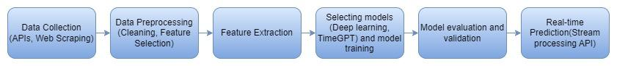

**Fig 4.1.1: Block Diagram of the system**

1. **Data Collection:** Gather historical and real-time Bitcoin price data from various sources, including cryptocurrency exchanges, news websites, social media platforms, and market sentiment data providers.
2. **Data Processing:** Use a streaming data processing framework to ingest real-time data.Process historical data using tools like Apache Spark or Hadoop. Handle missing values, outliers, and inconsistencies in the data.
3. **Feature Extraction:** Create relevant features, including technical indicators like moving averages, Relative Strength Index (RSI), and sentiment scores.
4. **Machine Learning Models:** Choose appropriate models, such as Long Short-Term Memory (LSTM) networks, Prophet, ARIMA, or machine learning algorithms like Random Forests or Gradient Boosting. Also utilization of TimGPT for reduced errors. Optimize model hyperparameters to improve accuracy.
5. **Model Evaluation and Validation:** Assess model performance using techniques like k-fold cross-validation.Validate predictions using historical data to simulate trading strategies. Measure model accuracy using metrics like Mean Absolute Error (MAE), Mean Squared Error (MSE), and Root Mean Squared Error (RMSE).
6. **Real-time Prediction:** Ensure that the prediction system can handle high-frequency real-time data.

**4.2. Modular diagram of the system:**

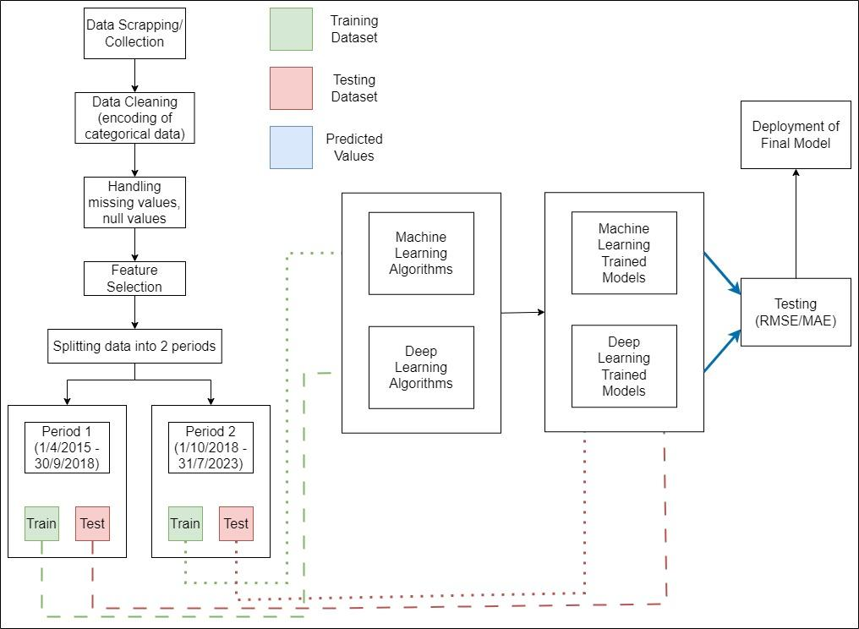

**Fig 4.2.1: Architectural Design**

1. The first step is to scrape/collect data from online websites like coinmarket to create a Bitcoin dataset that will be used for analysis and prediction.
2. Next step is to clean out the dataset. It involves steps like encoding categorical values and handling missing and null values.
3. Next we select the features that are highly likely to give accurate analysis of the price of bitcoin.
4. The dataset is then split into 2 time periods. The time periods are as follows: 1/4/2015 - 30/9/2018 and 1/10/2018 - current date.
5. The data from the above two time periods is further divided into individual training and testing dataset.
6. The training dataset is then fitted into different Machine Learning and Deep Learning algorithms to obtain the trained model of each algorithm.
7. The test data is then fed into the trained models to obtain the predictions made by the models.
8. Then we evaluate the performance of each of these models to obtain the model with the highest accuracy and deploy it for future use.

**4.3. Detailed Design**

**DFD Level 0:**

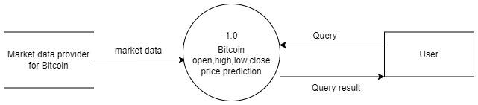

**Figure 4.3.1 DFD level 0**

The system takes historical Bitcoin price data (Market Data) and real-time data user queries (Price Prediction Query) as inputs. These inputs are processed internally to generate Bitcoin price predictions (Price Prediction) as outputs.This simplified view focuses on the core functionality of the system - transforming historical data into price forecasts based on user requests.

**DFD Level 1:**

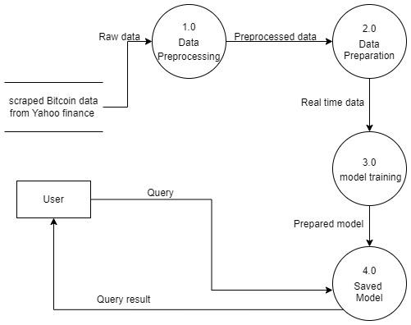

**Figure 4.3.2 DFD level 1**

This DFD Level 1 dives into the inner workings of the Bitcoin price prediction system. It reveals a multi-step process: first, historical data is collected. Then, the data is cleaned and formatted for real-time analysis. Next, models are trained on this data to learn historical price patterns. Finally, the system leverages the trained models to generate price predictions for next 30 days.

**4.4. Project Scheduling & Tracking using Time line / Gantt Chart:**

The Gantt chart of our project where we worked for the whole semester to create this model is shown in a timeline pattern. It is the most important part to think and design the planning of your topic and so we planned our work like the gantt chart shown.

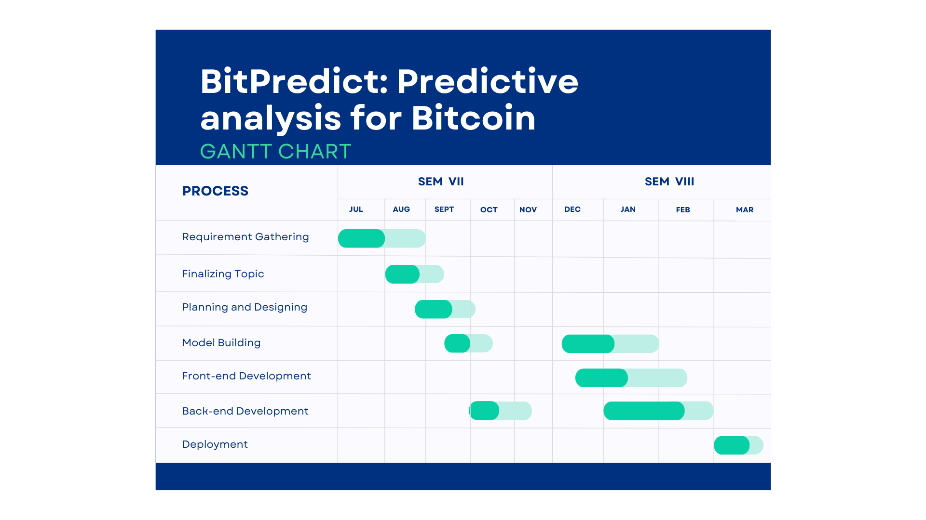

**Fig 4.4.1: Gantt Chart**

**Chapter 5: Implementation of the Proposed System**

| In this chapter, we document the actual development process of the proposed system. It covers the coding, configuration, and integration tasks involved in bringing the design to life, with a focus on implementation challenges and solutions. |
| --- |

**5.1.Methodology employed for development:**

The methodology for Bitcoin price prediction using deep learning involves the following steps:

1. **Data Collection:** Gather historical Bitcoin market data, including daily or hourly price, trading volume, and relevant indicators like moving averages, Relative Strength Index (RSI), and MACD. Additionally, collect social media sentiment data related to Bitcoin to incorporate market sentiment.
2. **Data Preprocessing:** Clean the collected data by handling missing values, outliers, and noise. Normalize or standardize the numerical features to ensure uniformity in the dataset. Perform feature engineering to create new meaningful features, such as rolling averages or volatility measures.
3. **Feature Selection:** Choose relevant features that have a significant impact on Bitcoin's price movement. Utilize techniques like correlation analysis or feature importance from machine learning and deep learning models.
4. **Model Selection:**

For time series forecasting, consider using Autoregressive Integrated Moving Average (ARIMA) for linear patterns, Long Short-Term Memory (LSTM) networks for capturing complex temporal patterns, and ensemble methods like Random Forest or Gradient Boosting for non-linear relationships. Additionally, TimeGPT, a variant of GPT designed for time series forecasting, offers advanced capabilities in capturing long-range dependencies and handling irregular time intervals, making it a powerful tool for forecasting tasks. Combining these methods based on data characteristics and forecasting requirements can lead to optimal forecasting performance.

1. **Model Training:** Split the dataset into training and validation sets. Train the selected models on historical data, adjusting hyperparameters to achieve optimal performance. For LSTM or other deep learning models, consider sequences of historical data.
2. **Model Evaluation:** Evaluate the trained models using appropriate evaluation metrics such as Mean Absolute Error (MAE), Root Mean Squared Error (RMSE), or Mean Absolute Percentage Error (MAPE). Compare the performance of different models and choose the best-performing one.
3. **Hyperparameter Tuning:** Fine-tune the hyperparameters of the chosen model(s) using techniques like grid search or random search to optimize performance further.
4. **Prediction and Testing:** Make predictions on new, unseen data to test the model's predictive accuracy. Monitor the model's performance over time and retrain it periodically to adapt to changing market conditions.
5. **Deployment:** Implement the trained model in a real-time or batch prediction environment, where it can provide updated price forecasts based on incoming data.
6. **Monitoring and Maintenance:** Continuously monitor the model's performance, retrain it with fresh data at regular intervals, and update the methodology as needed to ensure accurate predictions in a dynamic market environment.

**5.2.Algorithms:**

1. **Time Series Analysis:**
2. **ARIMA (AutoRegressive Integrated Moving Average):** ARIMA models are widely used for time series forecasting, including predicting Bitcoin prices.
3. **GARCH (Generalized Autoregressive Conditional Heteroskedasticity):** GARCH models are used to model volatility in financial time series data.
4. **TimeGPT:** TimeGPT, an advanced variant of the GPT model tailored for time series forecasting.

**2. Machine Learning Algorithms:**

1. **Linear Regression:** Linear regression models can be used for straightforward price prediction tasks.
2. **LSTM (Long Short-Term Memory) :** These deep learning algorithms are suitable for modeling sequential data, making them valuable for time series forecasting. TimeGPT, a variant of GPT (Generative Pre-trained Transformer), is another powerful tool designed specifically for time series forecasting. It leverages Transformer-based architectures to capture long-range dependencies and temporal patterns in sequential data, offering advanced capabilities beyond traditional LSTM networks. Combining LSTM and TIMEGPT models can enhance the accuracy and robustness of time series forecasting tasks.
3. **Recurrent Neural Network (RNN) :** It is a deep learning model that is trained to process and convert a sequential data input into a specific sequential data output.
4. **Gated Recurrent Unit (GRU) :** GRU is a type of recurrent neural network (RNN) architecture that is similar to LSTM (Long Short-Term Memory).
5. **Seasonal Autoregressive Integrated Moving Average (SARIMA) :** It's a statistical method used for time series forecasting, integrating autoregressive and moving average components with seasonality adjustments to predict future values based on past observations.

**3. Classification Algorithms:**

1. **Logistic Regression:** Logistic regression models can classify price movements as bullish or bearish.
2. **Decision Trees:** Decision trees and ensemble methods like Random Forest can be used for trend classification.

**5.3.Datasets source and utilization:**

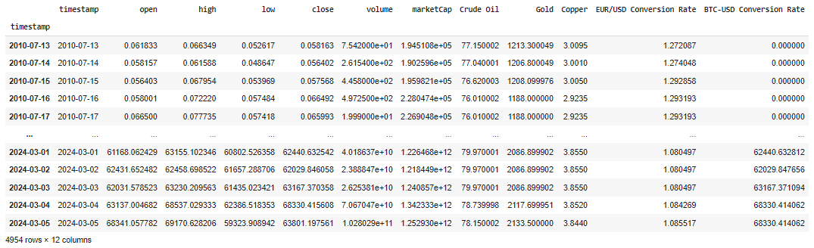

**Fig 5.3.1: Bitcoin Dataset sourced from CoinMarketCap (4054 rows and 12 columns)**

The utilization of datasets, particularly real-time Bitcoin data sourced from CoinMarketCap, is instrumental in advancing machine learning analysis and prediction within cryptocurrency markets. Spanning from July 13, 2010, to the present, these datasets offer a comprehensive historical perspective on Bitcoin's price evolution, encapsulating its inherent volatility, long-term trends, and intricate market dynamics. Such extensive data repositories serve as invaluable resources for researchers and analysts, enabling them to uncover underlying patterns and relationships that drive price movements. By harnessing sophisticated machine learning techniques such as LSTM, RNN, TimeGPT and GRU, practitioners can develop predictive models capable of capturing the complex nonlinearities inherent in cryptocurrency markets.

Moreover, the integration of real-time data ensures that these models remain adaptable and responsive to evolving market conditions, facilitating continuous refinement and improvement in predictive accuracy. This iterative process of model training and validation with the latest information from CoinMarketCap empowers stakeholders to make more informed decisions, optimize trading strategies, and navigate the dynamic landscape of cryptocurrency investments effectively. In essence, the utilization of these datasets is not only essential for understanding market behavior but also for driving innovation and enhancing performance in cryptocurrency price prediction endeavors.

**Chapter 6: Testing of the Proposed System**

| The testing chapter details the strategies and methodologies used to evaluate the functionality, performance, and reliability of the developed system. It includes test plans, scenarios, and results to validate that the solution meets the specified requirements |
| --- |

.**6.1.Introduction to Testing :**

Testing is an essential phase in the software development lifecycle (SDLC) that ensures the reliability, functionality, and quality of the developed software. It involves systematically executing the software components or system to identify any defects or errors that may affect its performance or user experience. The primary objective of testing is to validate whether the software meets the specified requirements and behaves as expected under different conditions.

**Importance of Testing :**

* **Cost Savings:** Catching bugs early in the development cycle is significantly cheaper than finding them after release.
* **Quality Assurance:** Testing helps ensure that the software functions as intended and is reliable.
* **User Satisfaction:** A well-tested product minimizes user frustration, builds trust, and translates into positive user experiences.
* **Security:** Testing can identify vulnerabilities and potential risks, protecting sensitive data.

**Levels of Testing:**

Testing occurs at different stages of software development with varying levels of granularity:

* **Unit Testing:** Isolates and tests individual units of code (functions, classes) for correctness. Performed primarily by developers.
* **Integration Testing:** Examines how different software components or modules interact with each other.
* **System Testing:** Evaluates the functionality and behavior of the complete, integrated software system against specified requirements.
* **Acceptance Testing:** Assesses if the software is ready for release from the end user's perspective. Often involves stakeholders or intended users.

**6.2 Types of testing considered:**

In our ML and DL model, we have considered various types of testing to ensure the robustness and effectiveness of the system. These include:

**1. User Interface Testing:** We conduct user interface testing to ensure that the BitPredict application's interface is user-friendly and intuitive. This involves assessing the clarity of labels, ease of navigation, and consistency of design elements to enhance user experience.

**2. Algorithm Performance Testing:** Our testing encompasses evaluating the performance of deep learning algorithms such as LSTM, RNN, and GRU. We assess the accuracy of predictions for key metrics such as Open, High, Low, and Close prices over a period, ensuring that the models provide effective forecasts.

**3. Long-Term Pattern Analysis:** With TimeGPT, we focus on capturing long-term patterns and dependencies in the data. Testing involves analyzing the model's ability to forecast trends accurately over extended periods, such as the next 5 or 10 days, to validate its effectiveness in capturing long-term dynamics.

**4. Error Analysis:** We conduct thorough error analysis to assess the accuracy of predictions generated by both deep learning algorithms and TimeGPT. By comparing predicted values with actual data, we identify and quantify errors to gauge the reliability and precision of the models.

**5. Trading Strategy Selection Testing:** Our testing also includes evaluating the functionality of the BitPredict application in offering users a selection of trading strategies. We ensure that users can choose from various strategies tailored to their trading preferences and risk appetites, enhancing the application's versatility and utility.

**6.3.Various test case scenarios considered:**

| Case | Test |
| --- | --- |
| 1. A well-designed user interface should be easily comprehended and navigated by the user. | BitPredict User Interface |
| 1. The deep learning models (LSTM,RNN,GRU) should provide effective predictions. | Open, High, Low, Close prediction trend |

| 1. The TimeGPT model should capture long-term patterns and dependencies in the data, enabling accurate forecasting. | Prediction trend by TimeGPT for next 10 days    Prediction trend by TimeGPT for next 5 days |
| --- | --- |
| 1. Users should be able to select from various trading strategies for buy / sell indication. | Selection of trading strategies |

**6.4.Inference drawn from the test cases:**

|  | Test Cases |
| --- | --- |
| 1. The BitPredict application's interface should be user-friendly with clear labels, intuitive navigation, and consistent design elements for easy comprehension and smooth navigation. |  |
| 1. The deep learning algorithms predict Bitcoin price for next 30 days but with high errors. | Deep Learning errors |
| 1. TimeGPT provides prediction for next 5 and next 10 days with comparatively lesser errors. | Errors for TimeGPT 10 days prediction    Errors for TimeGPT 5 days prediction |
| 1. The BitPredict application should offer users a selection of trading strategies to cater to diverse trading preferences and risk appetites. | Selection of trading strategies |

**Chapter 7: Results and Discussions**

| In this chapter we present and analyze the findings of our project, including performance metrics, user feedback, and comparisons with existing solutions. This chapter offers insights into the effectiveness and implications of the proposed system. |
| --- |

**7.1.Screenshot of Use Interface(UI) for the system:**

Our System UI displays price predictions utilizing the Simple Moving Average (SMA) strategy. SMA calculates the average price over a specific time period, smoothing out fluctuations to identify trends. By comparing short-term and long-term averages, the strategy predicts potential price movements. This approach is grounded in technical analysis, which aims to forecast future price action based on historical data patterns. The UI's visualization of SMA-based predictions offers traders insights into potential market trends, aiding decision-making processes in trading activities.



**Figure 7.1.1 The System UI showing the daily price prediction based on SMA strategy**

The System UI uses the Simple Moving Average (SMA) strategy to provide daily price predictions. It forecasts the open, high, low, and close values for the next day based on analyses of previous day's price data. By utilizing SMA, which calculates the average price over a specified period, the UI offers insights into potential market movements.



**Figure 7.1.2 The System UI showing the weekly price prediction based on SMA strategy**

Here the System UI employs the Simple Moving Average (SMA) strategy for weekly price forecasts. It projects the open, high, low, and close values for the upcoming week, drawing insights from historical price data. By applying SMA, which calculates average prices over defined intervals, the UI offers a comprehensive outlook on potential market trends over the week ahead.

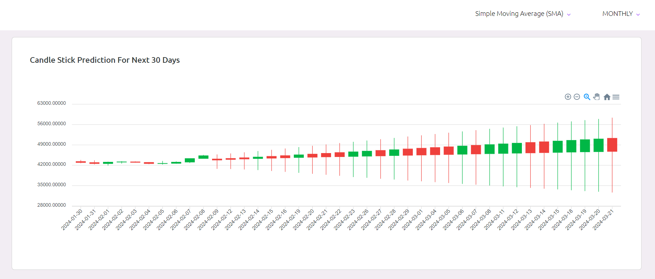

**Figure 7.1.3 The System UI showing the Candle stick prediction for next 30 days based on SMA strategy**

Here, the Candle stick prediction pattern is used for the next 30 days price forecasts drawing insights from historical price data. Candlestick patterns are visual representations of price movements over a specified time period. By incorporating SMA, which calculates the average price over a predetermined time frame, the UI predicts future candlestick patterns.

**7.2. Performance Evaluation Measures:**

MSE, RMSE, and MAE are common metrics used to evaluate the performance of regression models. They measure the difference between the predicted values and the actual values of the target variable.

**1. Mean Squared Error (MSE):**

- Definition: MSE measures the average squared difference between the predicted values and the actual values. It penalizes large errors more heavily than small errors.

- Formula:



- Where:

- n is the number of observations.

- yi is the actual value of the target variable for the ith observation.

- y^i is the predicted value of the target variable for the ith observation.

**2. Root Mean Squared Error (RMSE):**

- Definition: RMSE is the square root of the average squared difference between the predicted values and the actual values. It is a more interpretable measure than MSE because it is in the same units as the target variable.

- Formula:



- It's essentially the square root of MSE.

**3. Mean Absolute Error (MAE):**

- Definition: MAE measures the average absolute difference between the predicted values and the actual values. It provides a linear measure of the errors and is less sensitive to outliers compared to MSE.

- Formula:



In all formulas:

- n represents the number of observations.

- yi is the actual value of the target variable for the ith observation.

- y^i is the predicted value of the target variable for the ith observation.

**7.3. Input Parameters/Features considered:**

1. **Timestamp:** The date and time of each data point, allowing the model to capture temporal patterns and trends.
2. **Historical Price Data:** Open, high, low, and close prices of Bitcoin, providing information on price movements and volatility.
3. **Volume:** Trading volume of Bitcoin, indicating the level of market activity and liquidity.
4. **Market Capitalization:** Market capitalization of Bitcoin, reflecting its overall value in the market.
5. **Commodity Prices:** Prices of commodities such as crude oil, gold, and copper, which can be indicative of broader economic trends and influence investor sentiment.
6. **Currency Exchange Rates:** Exchange rates such as EUR/USD conversion rate, which can impact Bitcoin prices in the context of global economic conditions and currency dynamics.
7. **Other Cryptocurrency Prices:** Prices of other cryptocurrencies, as they can also influence Bitcoin prices through market interdependencies and investor behavior.

The utilization of various input parameters, including historical price data, trading volume, market capitalization, commodity prices (such as crude oil, gold, and copper), currency exchange rates, and prices of other cryptocurrencies, is imperative for comprehensive prediction and analysis of Bitcoin prices. This multifaceted approach allows the model to capture the intricate dynamics of cryptocurrency markets, which are influenced by a myriad of factors spanning economic, financial, and technological domains. By incorporating a diverse set of input parameters, the model can effectively account for external influences and market interdependencies, enabling a more accurate assessment of Bitcoin price movements. Moreover, the inclusion of commodity prices and currency exchange rates provides insights into broader economic trends and investor sentiment, helping to contextualize Bitcoin's value proposition as a digital asset and store of wealth. Additionally, considering prices of other cryptocurrencies allows for the examination of market correlations and investor behavior across the cryptocurrency ecosystem. Overall, the utilization of a comprehensive range of input parameters enhances the predictive power of the model, mitigates risks associated with market uncertainties, and facilitates a deeper understanding of the underlying drivers shaping Bitcoin prices.

**7.4. Graphical and statistical output:**

Graphical output presents data visually through charts, graphs, and diagrams. It enables users to quickly grasp complex information and identify trends or patterns. Common types of graphical output include line charts, bar charts, pie charts, scatter plots, and histograms. In financial analysis, candlestick charts are frequently used to represent price movements over time, displaying open, high, low, and close prices for a given period. These visualizations aid traders and analysts in identifying market trends, patterns, and potential trading opportunities.

Statistical output provides numerical summaries and analyses of data, offering insights into central tendencies, variations, correlations, and trends within datasets. Statistical output includes measures such as mean, median, standard deviation, correlation coefficients, and regression analysis results. In financial forecasting, statistical output might include Simple Moving Average (SMA) values, prediction accuracy metrics (e.g., Mean Absolute Error, Root Mean Squared Error), and trend analysis indicators. These statistical insights provide quantifiable measures of prediction performance and help validate the reliability of forecasting models.

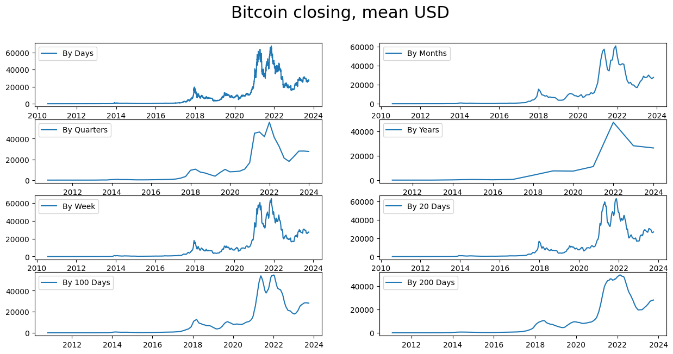

**Fig 7.4.1. Graph for bitcoin closing values from 2012-2024 (days, months, quarters, years, week, 20 days, 100 days, 200 days)**

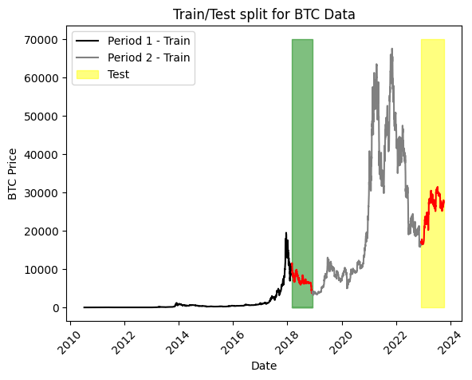 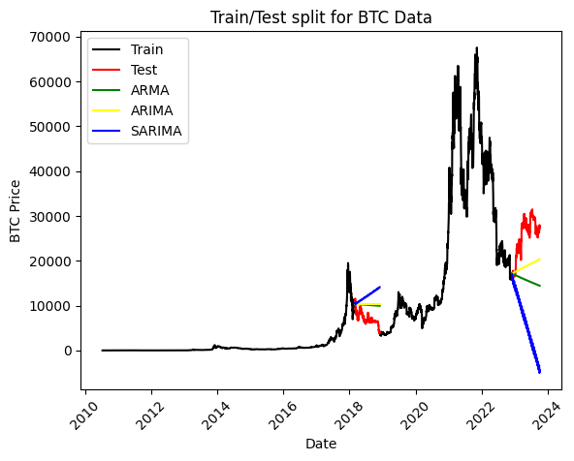 **Figure 7.4.2. Training and testing of BTC data Figure 7.4.3. Time Series Models**

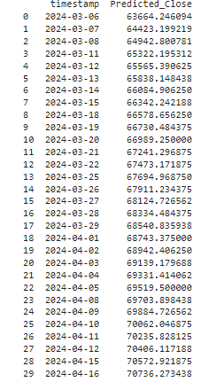 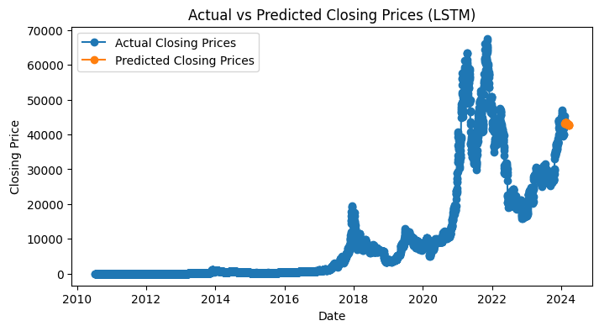

**Fig.7.4.4. Actual vs Predicted Closing Prices (LSTM Model)**

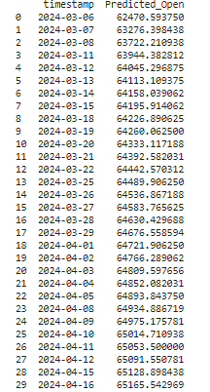 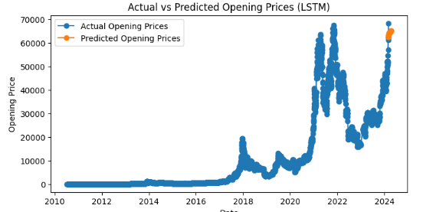

**Fig.7.4.5. Actual vs Predicted Opening Prices (LSTM Model)**

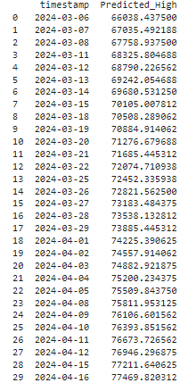 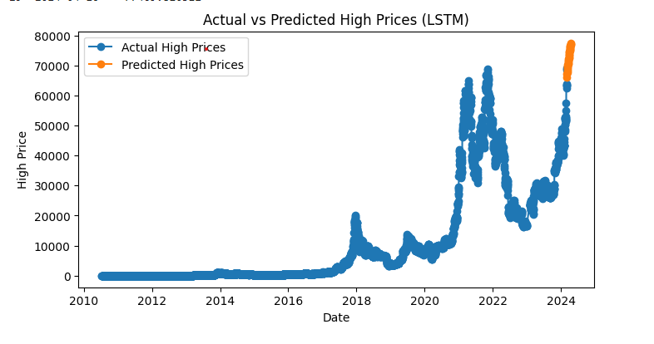

**Fig.7.4.6. Actual vs Predicted High Prices (LSTM Model)**

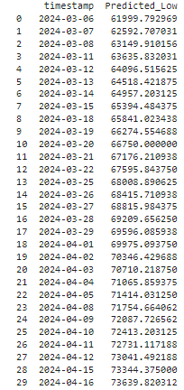 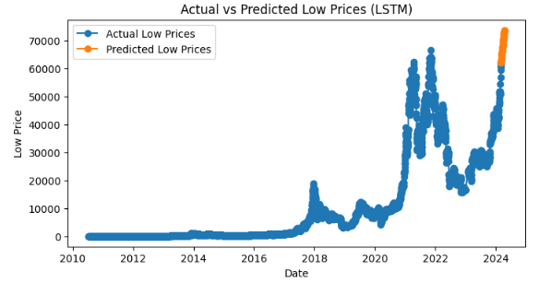

**Fig.7.4.7. Actual vs Predicted Low Prices (LSTM Model)**

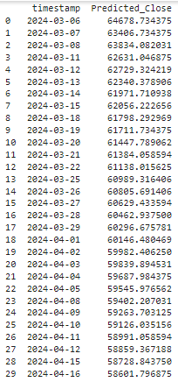 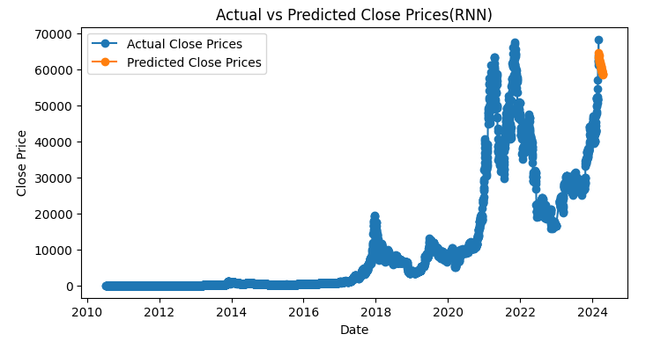

**Fig.7.4.8. Actual vs Predicted Close Prices (RNN Model)**

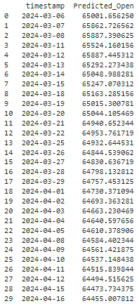 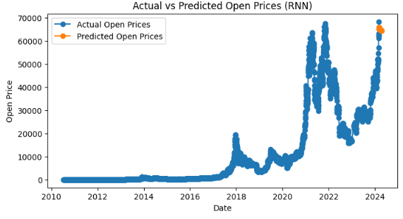

**Fig.7.4.9. Actual vs Predicted Open Prices (RNN Model)**

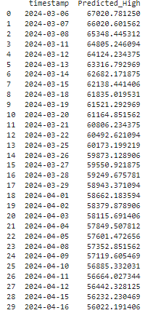 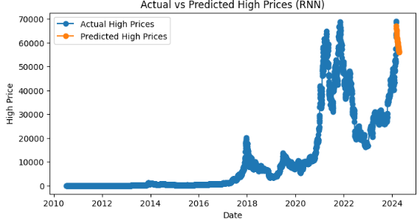

**Fig.7.4.10. Actual vs Predicted High Prices (RNN Model)**

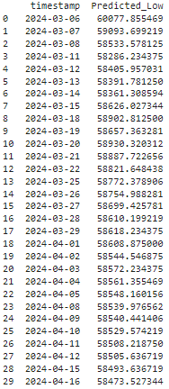 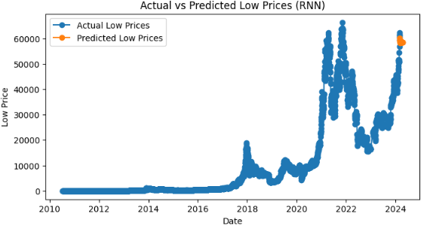

**Fig.7.4.11. Actual vs Predicted Low Prices (RNN Model)**

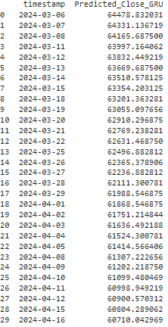 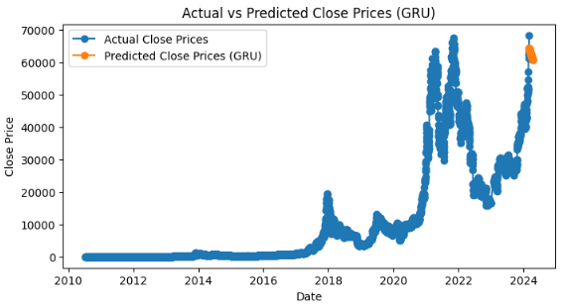

**Fig.7.4.12. Actual vs Predicted Close Prices (GRU Model)**

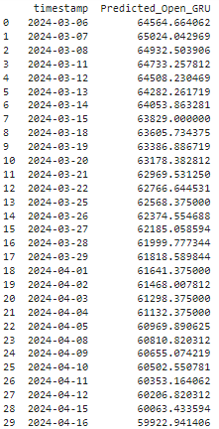 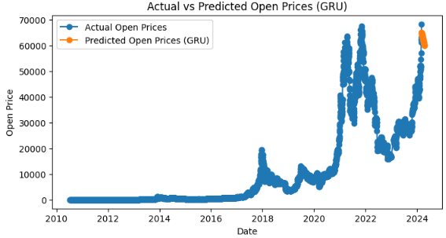

**Fig.7.4.13. Actual vs Predicted Open Prices (GRU Model)**

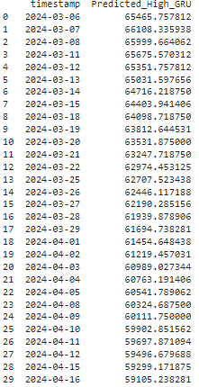 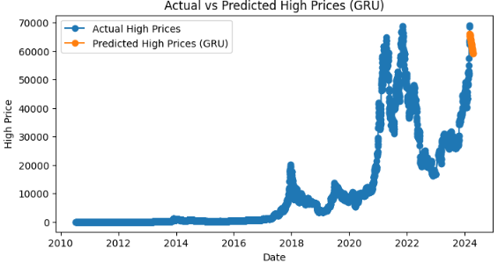

**Fig.7.4.14. Actual vs Predicted High Prices (GRU Model)**

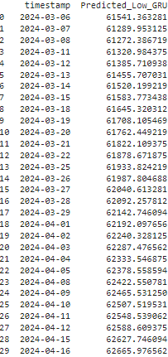 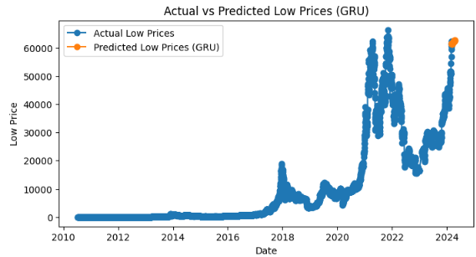

**Fig.7.4.15. Actual vs Predicted Low Prices (GRU Model)**

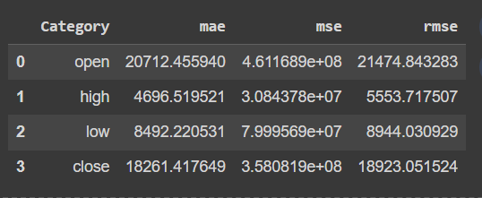 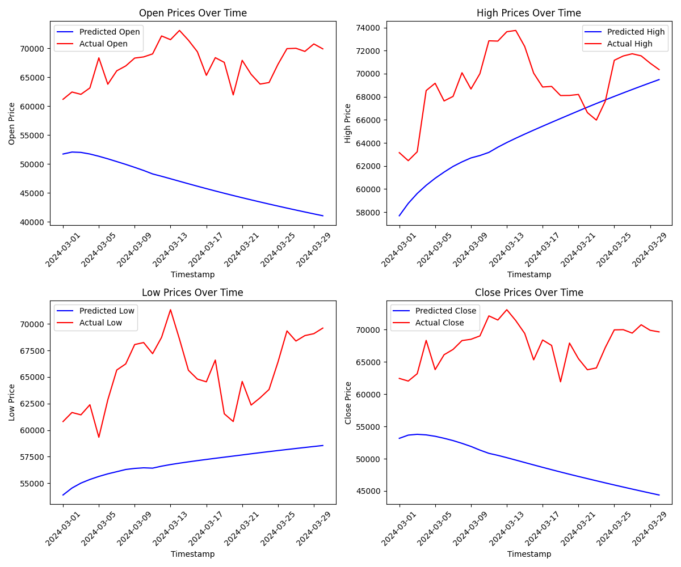

**Fig.7.4.16. Open, High, Low, Close error values (mae,mse,rmse) for Deep Learning Algorithms**

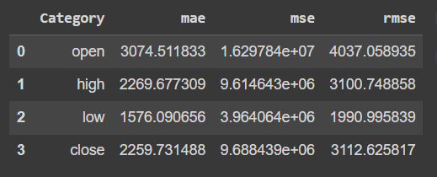 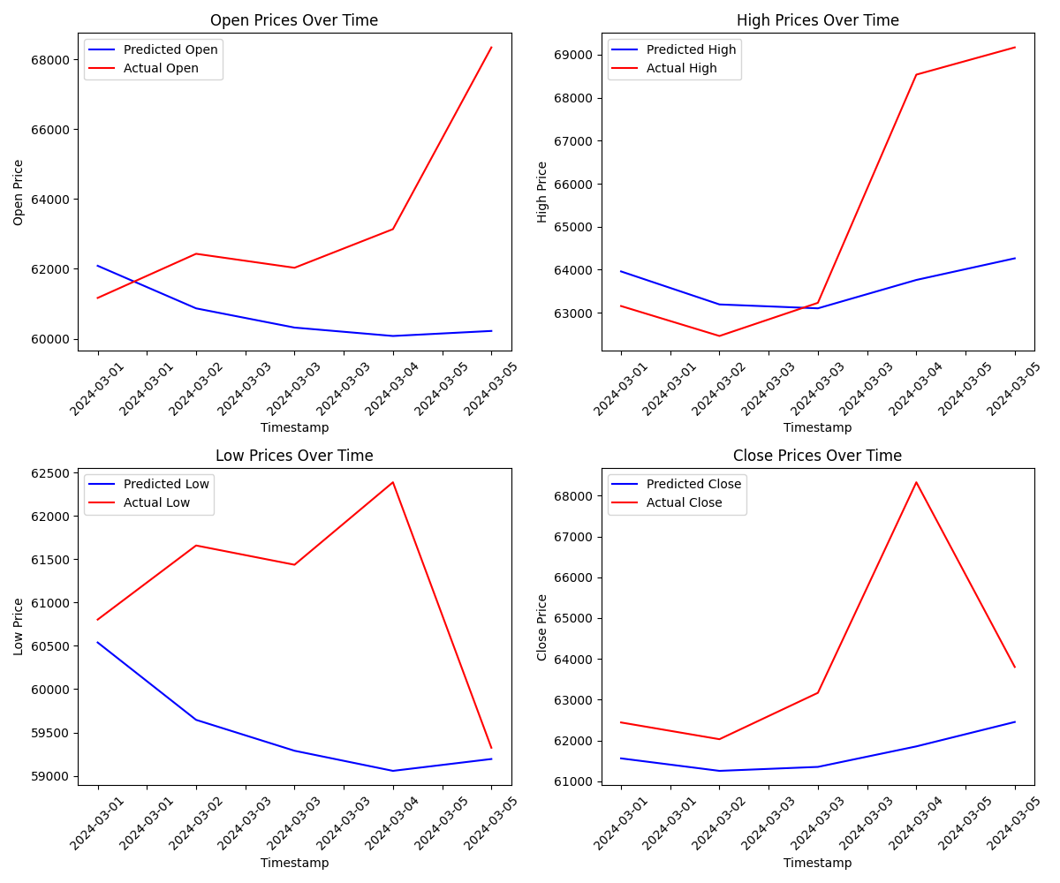

**Fig.7.4.17. Open, High, Low, Close error values (mae, mse, rmse) by TimeGPT for 5 days**

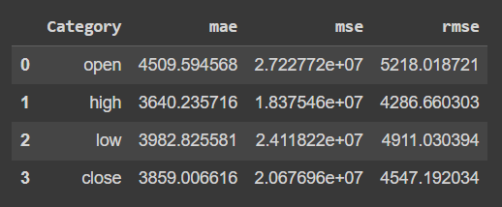 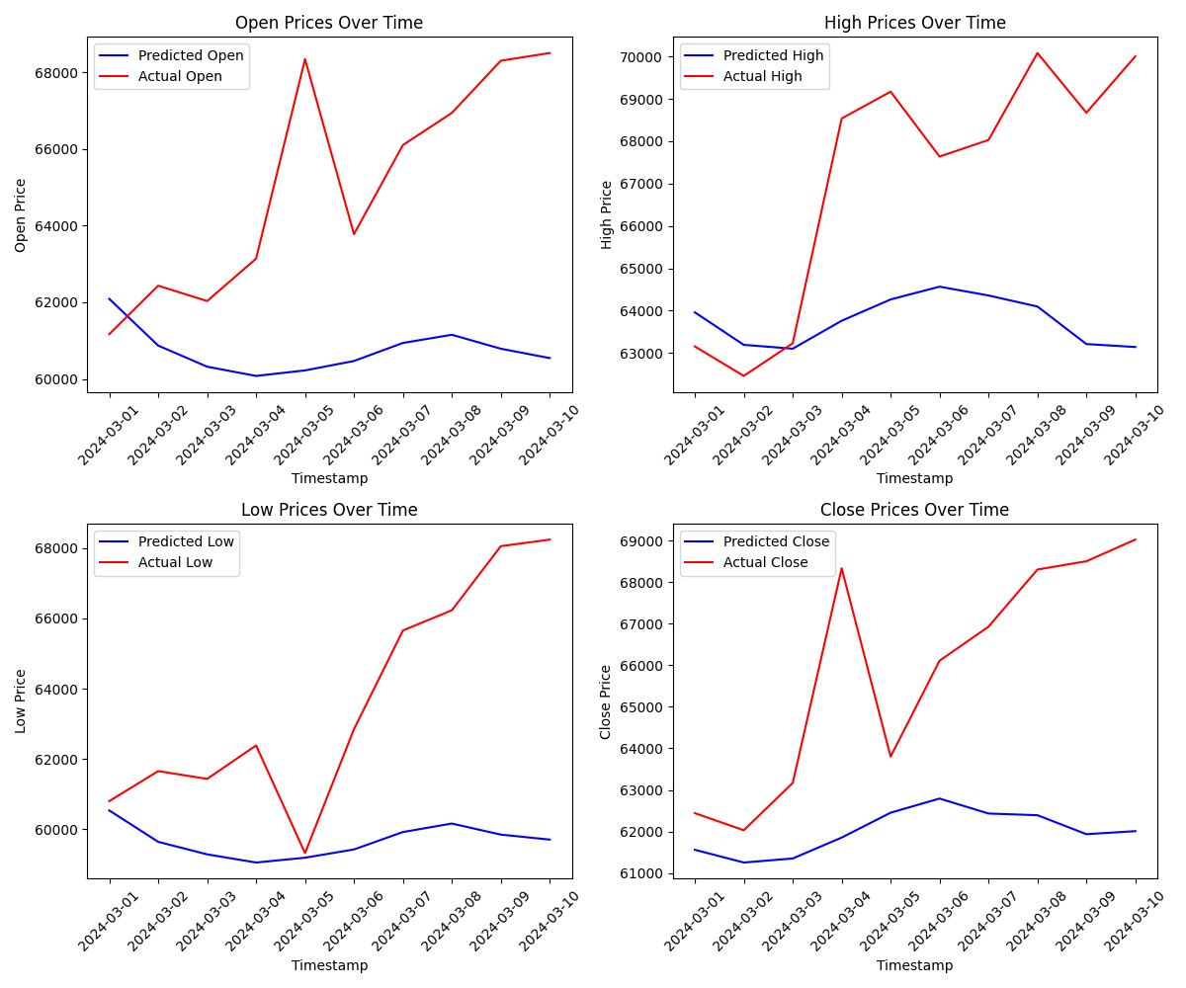

**Fig.7.4.18. Open, High, Low, Close error values (mae, mse, rmse) by TimeGPT for 10 days**

**7.5. Comparison of Results with Existing System:**

**Table 7.5 : Comparison of Results with Existing System**

| **Criteria** | **Existing Systems** | **BitPredict** |
| --- | --- | --- |
| Prediction Accuracy | Variable, with differing levels of accuracy | Consistently low errors, indicating high accuracy |
| Error Rates | Error rates may vary depending on the model | Lowest errors compared to existing models |
| Stability | Some models may exhibit instability due to market changes | Your system shows stability with continuous learning capabilities |
| Adaptability | Limited adaptability to sudden market changes | High adaptability due to continuous learning with real-time data |
| Performance Over Time | May require periodic recalibration or updates | Continuously improves performance with real-time data updates |
| Computational Efficiency | Efficiency may vary depending on model complexity | May require more computational resources due to complex architecture |
| Real-Time Updates | Limited or batch updates with new data | Provides continuous updates with real-time data feeds |
| Interpretability | Some models offer interpretability | Interpretability may be challenging due to the complexity of TimeGPT |
| Scalability | Limited scalability due to computational constraints | Scalability may be limited by computational resources |

**7.6. Inference Drawn:**

The comparison table outlines significant advantages of your system, particularly TimeGPT, over existing methodologies in Bitcoin price prediction. Notably, TimeGPT consistently demonstrates lower error rates compared to existing models, indicating superior predictive accuracy. This precision is pivotal for investors and traders navigating the volatile cryptocurrency market, providing them with reliable insights for informed decision-making. Furthermore, TimeGPT's stability over time, driven by its continuous learning capabilities, offers a distinct advantage. Unlike existing models prone to instability amidst market fluctuations, TimeGPT maintains a steady performance trajectory, ensuring reliability in its predictions.

Moreover, your system exhibits high adaptability to abrupt market shifts, facilitated by its continuous learning mechanism with real-time data feeds. This flexibility enables TimeGPT to swiftly respond to changing market dynamics, ensuring the relevance and effectiveness of its predictions even in rapidly evolving conditions. Additionally, the provision of continuous updates with real-time data feeds enhances the system's utility, empowering stakeholders with timely insights for decision-making. However, it's essential to acknowledge potential challenges such as computational efficiency and interpretability. TimeGPT's complex architecture may necessitate greater computational resources, potentially impacting scalability and resource allocation. Furthermore, interpretability may pose a challenge due to the intricacies of TimeGPT's functioning. Nonetheless, the overall superiority of your system, characterized by its accuracy, stability, adaptability, and real-time updates, positions it as a compelling solution for Bitcoin price prediction in the cryptocurrency market landscape.

**Chapter 8: Conclusion**

| The conclusion chapter wraps up our blackbook by summarizing the project's objectives,  achievements, and contributions. It reflects on the challenges encountered, lessons learned, and p potential future directions for further research or improvements. |
| --- |

**8.1.Comparison of models:**

**DL -** Deep Learning

**Tgpt5 -** TimeGPT for 5 Days

**Tgpt10** - TimeGPT for 10 Days

**Table 8.1 Comparison of models**

|  | **Open mae** | **Open mse** | **Open rmse** | **Highmae** | **High mse** | **High rmse** | **Lowmae** | **Lowmse** | **Low rmse** | **Closemae** | **Closemse** | **Closermse** |
| --- | --- | --- | --- | --- | --- | --- | --- | --- | --- | --- | --- | --- |
| **DL** | 20712.45594 | 4.611689e+0 | 21474.84328 | 4696.519521 | 3.084378e+0 | 5553.717507 | 8492.220531 | 7.999569e+0 | 8944.030929 | 18261.41764 | 3.580819e+0 | 18923.05152 |
| **Tgpt5** | 3074.511833 | 1.629784e+0 | 4037.058935 | 2269.677309 | 9.614643e+0 | 3100.748858 | 1576.090656 | 3.964064e+0 | 1990.995839 | 2259.731488 | 9.688439e+0 | 3112.625817 |
| **Tgpt10** | 4509.594568 | 2.722772e+0 | 5218.018721 | 3640.235716 | 1.837546e+0 | 4286.660303 | 3982.825581 | 2.411822e+0 | 4911.030394 | 3859.006616 | 2.067696e+0 | 4547.192034 |

**Deep Learning (DL):** Despite being a conventional and widely-used method, DL exhibits higher errors across all metrics compared to TimeGPT models for both short-term (Tgpt5) and long-term (Tgpt10) predictions. This suggests that DL may struggle with capturing the nuanced patterns in Bitcoin price data.

**TimeGPT Models (Tgpt5 and Tgpt10):** These transformer-based models show promising results, particularly in terms of lower error rates across all prediction horizons and price aspects. Notably, Tgpt5 outperforms Tgpt10 in certain aspects, indicating potential diminishing returns with longer prediction horizons.

Error Metrics: RMSE generally tends to penalize large errors more severely than MAE due to squaring the errors, making it a more sensitive metric. However, in the context of financial predictions, it's essential to consider both MAE and RMSE for a comprehensive assessment of model performance.

In conclusion, the analysis highlights the efficacy of transformer-based models like TimeGPT in Bitcoin price prediction compared to traditional methods like Deep Learning. However, further research and experimentation may be warranted to optimize these models for even more accurate forecasts.

**8.2.Limitations:**

**1. Data Quality and Availability:** The reliability of predictions heavily depends on the quality and availability of historical data. Limited or unreliable data can lead to inaccurate predictions and reduced model performance.

**2. Market Volatility:** Cryptocurrency markets, including Bitcoin, are highly volatile and influenced by numerous factors such as news events, regulatory changes, and market sentiment. Sudden and unpredictable fluctuations can challenge the ability of the models to accurately predict prices.

**3. Model Overfitting:** Deep learning models like LSTM, RNN, and GRU are susceptible to overfitting, where the model performs well on training data but poorly on unseen data. Overfitting can occur if the model captures noise or specific patterns that are not representative of the underlying data generating process.

**4. Generalization:** Models trained on historical data may not generalize well to unseen data or new market conditions. Changes in market dynamics or the emergence of new influential factors may render the models less effective over time.

**5. Ethical and Regulatory Considerations:** Predictive models in financial markets raise ethical concerns related to potential market manipulation or unfair advantage. Moreover, regulatory constraints and compliance requirements may impose limitations on the deployment and operation of the prediction system.

**6. Uncertainty and Risk:** Predictions generated by the models are inherently uncertain and carry risks. Users should be aware that predictions are probabilistic estimates and not definitive forecasts, and they should exercise caution when making investment decisions based solely on model outputs.

Addressing these limitations requires a comprehensive understanding of the underlying data and market dynamics, robust model development and validation processes, continuous monitoring and refinement of models, and adherence to ethical and regulatory standards.

**8.3.Conclusion:**

In the pursuit of identifying the most effective method for forecasting Bitcoin prices, a thorough examination of various time series analysis and machine learning algorithms was conducted. Options such as ARIMA, GARCH, linear regression, LSTM, RNN, GRU, SARIMA, logistic regression, and decision trees were rigorously assessed. However, upon evaluation, TimeGPT emerged as the optimal solution due to its remarkable performance metrics. TimeGPT, an advanced variant of the GPT model, specifically tailored for time series forecasting, exhibited the lowest errors compared to other contenders. Leveraging the transformer-based architecture, TimeGPT excels in capturing intricate temporal patterns and dependencies within the Bitcoin price data, thereby enabling precise predictions.

Given its exceptional performance and adaptability, TimeGPT has been selected as the preferred approach for forecasting Bitcoin prices. The model's proficiency lies in its ability to analyze sequences of data comprehensively, providing contextually relevant forecasts that aid in making well-informed investment decisions. By harnessing TimeGPT's capabilities, stakeholders can navigate the volatile cryptocurrency market landscape with greater confidence, leveraging accurate predictions to optimize trading strategies and maximize returns. Thus, the decision to advance with TimeGPT signifies a strategic move towards harnessing cutting-edge technology to enhance predictive accuracy and drive success in cryptocurrency trading endeavors.

**8.4.Future Scope:**

1. Continuously enhancing model accuracy and reliability.

2. Integrating with trading platforms for real-time insights.

3. Developing risk management tools for investors.

4. Expanding to include other cryptocurrencies in portfolio optimization.

5. Incorporating sentiment analysis to gauge market sentiment.

6. Utilizing for blockchain analytics and market research.

7. Exploring applications in decentralized finance (DeFi).

8. Providing educational resources for cryptocurrency markets.

9. Developing regulatory compliance solutions for monitoring.

10. Expanding to include AI-driven trading strategies

**References**

1. <https://www.forbes.com/advisor/in/investing/cryptocurrency/why-is-crypto-going-up>
2. <https://explodingtopics.com/blog/number-of-cryptocurrencies>
3. <https://triple-a.io/crypto-ownership-data>
4. <https://www.statista.com/statistics/1272903/cryptocurrency-trade-volume>
5. Monish S, Mridul Mohta, Shanta Rangaswamy, “Ethereum price prediction using machine learning - a comparative study”, International Journal of Engineering Applied Sciences and Technology, 2022, Vol. 7, Issue 2, ISSN No. 2455-2143, Pages 137-142
6. Salim Lahmiri, Stelios Bekiros, “Deep Learning Forecasting in Cryptocurrency High‐Frequency Trading”, Received: 28 October 2020 / Accepted: 15 January 2021,Published online: 2 February 2021, Cognitive Computation (2021) 13:485–487
7. Ahmad Bilal Wardak, Jawad Rasheed, “Bitcoin Cryptocurrency Price Prediction Using Long Short-Term Memory Recurrent Neural Network”, European Journal of Science and Technology, No. 38, pp. 47-53, August 2022, Copyright © 2022 EJOSAT
8. Neha Mangla, Akshay Bhat, Ganesh Avabratha, Narayana Bhat, “Bitcoin Price Prediction Using MachineLearning”, INTERNATIONAL JOURNAL OF INFORMATION AND COMPUTING SCIENCE, ISSN NO: 0972-1347
9. S M Rajua, Ali Mohammad Tarif, “Real-Time Prediction of BITCOIN Price using Machine Learning Techniques and Public Sentiment Analysis”
10. K. Ramya Laxmi , Marri Abhinandhan Reddy, CH. Shivasai3, P. Sandeep Reddy, “Cryptocurrency Price Prediction Using Machine Learning”, SAMRIDDHI Volume 12, Special Issue 3, 2020 Print ISSN : 2229-7111 Online ISSN : 2454-5767
11. Shengao Zhang, Mengze Li and Chunxiao Yan, “The Empirical Analysis of Bitcoin Price Prediction Based on Deep Learning Integration Method”, Hindawi Computational Intelligence and Neuroscience Volume 2022, Article ID 1265837, 9 pages, https://doi.org/10.1155/2022/1265837
12. Siddhi Velankar, Sakshi Valecha, Shreya Maji, “Bitcoin Price Prediction using Machine Learning”, International Conference on Advanced Communications Technology(ICACT)
13. Zheshi Chen, Chunhong Li, Wenjun Sun, “Bitcoin price prediction using machine learning: An approach to sample dimension engineering”,Journal of Computational and Applied Mathematics 365 (2020) 112395
14. Lekkala Sreekanth Reddy, Dr.P. Sriramya, “A Research On Bitcoin Price Prediction Using Machine Learning Algorithms”, INTERNATIONAL JOURNAL OF SCIENTIFIC & TECHNOLOGY RESEARCH VOLUME 9, ISSUE 04, APRIL 2020 ISSN22778616 1600 IJSER©2020
15. Mrs Vaidehi, Alivia Pandit, Bhaskar Jindal, Minu Kumari and Rupali Singh, “Bitcoin Price Prediction using Machine Learning”, Original Article International Journal of Engineering Technologies and Management Research, ISSN (Online): 2454-1907, May 2021 8(5), 20–28
16. Guru Pradeep, Harishvaran , Amsavalli, “Cryptocurrency Price Prediction using Machine Learning”, International Journal of Advanced Research in Computer and Communication Engineering ISO 3297:2007 CertifiedImpact Factor 8.102 Peer-reviewed / Refereed journal Vol. 12, Issue 4, April 2023, DOI: 10.17148/IJARCCE.2023.124140
17. Saachin Bhatt, Mustansar Ghazanfar, and Mohammad Hossein Amirhosseini, “MACHINE LEARNING BASED CRYPTOCURRENCY PRICE PREDICTION USING HISTORICAL DATA AND SOCIAL MEDIA SENTIMENT”
18. Junwei Chen, “Analysis of Bitcoin Price Prediction Using Machine Learning”, Journal of Risk and Financial Management
19. Mohammed khalid salman and Abdullahi Abdu Ibrahim, “PRICE PREDICTION OF DIFFERENT CRYPTOCURRENCIES USING TECHNICAL TRADE INDICATORS AND MACHINE LEARNING”, 2020 IOP Conf.
20. Amritha, Asrafunisha, Nandhini, Pushpalatha, “MODIFYING AND PREDICTING OF CRYPTOCURRENCY PRICES USING DATA SCIENCE TECHNIQUE”, Vol-8 Issue-3 2022 IJARIIE-ISSN(O)-2395-4396
21. Samiksha Marne, Delisa Correia, Shweta Churi, Joanne Gomes, “Predicting Price of Cryptocurrency - A Deep Learning Approach”,International Journal of Engineering Research & Technology (IJERT), ISSN: 2278-0181, NTASU - 2020 Conference Proceedings
22. Abdussalam Aljadani, “DLCP2F: a DL‐based cryptocurrency price prediction framework”, September 2022
23. Snega.S, Nivedha. B, Ramachandran C.A, “Bitcoin Price Prediction Using ML'', Electronic copy available at: https://ssrn.com/abstract=4128261

**1] Paper**

BitPredict: Predictive Analytics for Bitcoin

Teesha Karotra Tithi Jhamnani Dimple Madhwani

dept. of Computer Engineering dept. of Computer Engineering dept. of Computer Engineering

VESIT VESIT VESIT

Mumbai, India Mumbai,India Mumbai,India

2020.tithi.jhamnani@ves.ac.in 2020.teesha.karotra@ves.ac.in 2020.dimple.madhwani@ves.ac.in

Aditi Salvi Dr.(Mrs) Sujata Khedkar

dept. of Computer Engineering dept. of Computer Engineering

VESIT VESIT

Mumbai,India Mumbai,India

d2020.aditi.salvi@ves.ac.in sujata.khedkar@ves.ac.in

**ABSTRACT**

***The global financial scene has witnessed a surge in cryptocurrency popularity, notably Bitcoin, with a market cap hitting $1.18 trillion in July 2023. This growth underscores both potential and volatility in this emerging asset class, prompting exploration of novel approaches. Integrating Machine Learning (ML) and Artificial Intelligence (AI) with Bitcoin trading has garnered attention. This study investigates leveraging ML-assisted trading to exploit market inefficiencies for abnormal gains. With over 22,904 cryptocurrencies, 8823 active, and a $1.08 trillion market valuation, the crypto market showcases remarkable growth. The research involves Bitcoin price prediction using historical market data and employs various ML and deep learning algorithms, including ARIMA, LSTM, Random Forest, and revolutionary model like TimeGPT.***

**Keywords:**

Cryptocurrency, Bitcoin, Machine Learning, Artificial Intelligence, Market Prediction, Trading, Financial Landscape, Market Capitalization, Time Series Models, ARIMA, LSTM, Regression Models, Random Forest, TimeGPT, Ensemble Techniques, Hyperparameter Tuning, Crypto Market, Financial Innovation.

1. **Introduction:**

In a dynamic and volatile cryptocurrency market, predicting the future price of assets like Bitcoin has become pivotal for traders and investors. This project endeavors to harness the power of deep learning to forecast Bitcoin prices based on historical market data. By leveraging features such as trading volume, volatility, sentiment analysis from social media, and macroeconomic indicators, this deep learning model aims to provide accurate short-term and long-term price forecasts.

The project's significance lies in its potential to enhance cryptocurrency trading strategies, allowing market participants to make informed decisions and navigate the complexities of the ever-evolving digital asset landscape. Through sophisticated algorithms and data-driven insights, this project aims to contribute to a more efficient and informed approach to cryptocurrency trading, thereby benefiting the broader market.

1. **Motivation:**

The motivation behind this research project stems from the critical need for advanced tools and methodologies to navigate the inherently volatile and dynamic cryptocurrency market, particularly concerning the valuation of assets like Bitcoin. Cryptocurrency trading presents unique challenges due to the absence of centralized regulation, rapid market fluctuations, and the influence of sentiment-driven factors. Traditional financial models often struggle to capture the intricacies of this emerging market, warranting the exploration of innovative approaches.

This research is motivated by the desire to bridge the gap between conventional financial analysis and the evolving nature of cryptocurrency trading. By leveraging the capabilities of deep learning, the project seeks to enhance predictive modeling for Bitcoin prices, providing traders and investors with a valuable tool to navigate the complexities of this digital asset landscape. The motivation further lies in addressing the pressing need for accurate, data-driven insights that can empower market participants to make informed decisions amid the rapidly changing dynamics of the cryptocurrency market.

**III. Literature survey:**   
[1] discusses the growing interest in Bitcoin price prediction due to its attractiveness in terms of return and risk. Advances in machine learning, especially deep learning, have put Bitcoin price prediction in the spotlight. The efficient markets hypothesis assumes that stock prices will move randomly, but machine learning tools challenge this notion. A variety of models, including long-term memory and neural networks, have been used to predict stock and cryptocurrency prices. This paper presents a deep feedforward neural network (DFNN) for high-frequency Bitcoin price prediction and evaluates its performance using various learning algorithms. The results highlight the effectiveness of the Levenberg-Marquardt algorithm compared to the Powell-Beale restart and robust algorithms. [2] explores the growing popularity of cryptocurrencies, focusing on the second most popular cryptocurrency, Ethereum. This paper highlights the transformative power of blockchain, the technology underlying cryptocurrencies, in transforming financial systems. We discuss the value proposition of Ethereum as a universal investment and medium of exchange and contrast its price volatility compared to traditional stocks due to 24/7 trading. In this study, we compare three models: recurrent neural network (RNN), long short-term memory (LSTM), and bidirectional LSTM, to predict short-term (30 days) and long-term (90 days) Ethereum price using a dataset. Over 2000 days. Evaluation metrics include Mean Absolute Percentage Error (MAPE), Root Mean Square Error (RMSE), and Mean Absolute Error (MAE). Results support a two-way LSTM model for accurate price predictions, providing insight into the dynamic nature of cryptocurrency markets. [3] explores cryptocurrency price prediction methodologies, focusing on neural networks and deep learning. Previous research has extensively studied LSTM and GRU models and demonstrated their effectiveness for Bitcoin price prediction. Comparative analysis using existing models, including ARIMA, have consistently demonstrated the superior accuracy of recurrent neural networks in identifying volatility characteristics of cryptocurrency markets. Other approaches such as genetic programming to optimize model features to improve prediction performance have also been studied. These studies collectively highlight the growing importance of deep learning mechanisms in financial markets for time series forecasting, especially in the context of cryptocurrencies. The existing body of research provides a comprehensive foundation for the current research focus on LSTMs, strengthening their role as a powerful tool for accurate and efficient cryptocurrency price predictions. [4] The purpose of this article is to accurately estimate the price of Bitcoin by analyzing various influencing parameters. With a focus on daily market changes, we use machine learning, specifically Logistic Regression, Support Vector Machines, ARIMA, and Recurrent Neural Networks (RNNs) with Long Short-Term Memory (LSTM) cells. This study uses a dataset covering the period from October 10, 2015 to March 1, 2019. ARIMA performs well for short-term predictions, while RNN consistently predicts 6 days. Logistic regression is effective for separable hyperplanes, and SVM achieves 48% accuracy. This article helps you understand Bitcoin price dynamics by demonstrating the potential of machine learning in cryptocurrency prediction.

[5] aims to predict Bitcoin prices by considering various parameters influencing its value. The study spans two phases: firstly, understanding daily trends in the Bitcoin market and identifying optimal features, and secondly, predicting the sign of daily price changes. Leveraging machine learning, Bayesian regression, Generalized Linear Model (GLM), and Random Forest are considered. The literature survey explores existing models, such as GLM/Random Forest on various time series data sets, emphasizing the importance of predictive power for market excess return. The ongoing work involves database collection, normalization using techniques like log transformation and Z-score, and exploration of Bayesian regression and GLM/Random Forest for accurate Bitcoin price prediction.

[6] The literature on Bitcoin price prediction has responded to its transition from a medium of exchange to an investment asset amid cryptocurrency market volatility. Researchers increasingly employ machine learning (ML) techniques for accurate predictions, yet limited attention is given to diverse modeling techniques across various data structures. This study addresses the gap by focusing on daily and high-frequency Bitcoin price predictions. While existing research leverages ML models such as recurrent neural networks, the novel contribution lies in classifying Bitcoin price data based on intervals. Simple statistical methods outperform complex ML models for daily predictions, emphasizing the importance of sample dimension in ML techniques. This pilot study sets the stage for future research in industrial prediction problems within the realm of machine learning.

[7] explores project-based learning in software engineering and its application to cryptocurrency price prediction, focusing on Bitcoin. It highlights the importance of fostering creativity and practical skills through real-world projects. The review discusses the use of trained machine models for predicting cryptocurrency prices, emphasizing the significance of utilizing the right data and computational leverage for accurate predictions. Previous studies employ diverse models, including Bayesian regression, GLM/Random Forest, LSTM, and ARIMA, to forecast Bitcoin prices. Challenges in these approaches include time-consuming data filtering processes and low redundancy for predictions. The overview underscores the growing interest in leveraging AI techniques to handle large datasets and make precise predictions in the dynamic cryptocurrency market. The literature review provides a foundational understanding of the existing methodologies, setting the stage for the proposed approach that incorporates the LASSO algorithm and emphasizes the efficient handling of large datasets for quicker and accurate Bitcoin price predictions.

[8] The literature on Bitcoin price prediction, particularly using machine learning and deep neural networks, demonstrates a significant focus on models like Biological Neural Networks, Recurrent Neural Networks, and Long Short-Term Memory. Notably, the study by M. V. M., A. P., B. J., M. K., & R. S. (2021) utilizes Bayesian optimized Recurrent Neural Network (RNN) and Long Short-Term Memory (LSTM) for predicting Bitcoin prices 30 days ahead, achieving a classification accuracy of 52%. The literature underscores the challenges of predicting cryptocurrency prices due to dynamic market forces, emphasizing the superiority of deep learning methods over traditional models like AutoRegressive Integrated Moving Average (ARIMA). Continuous exploration of novel features and adaptable modeling approaches is encouraged for improved predictive accuracy in the evolving cryptocurrency landscape.

[9] delves into the dynamic realm of cryptocurrency price prediction using machine learning. Highlighting Bitcoin's volatility and unpredictability, the study explores various methodologies, including regression, time series analysis, and deep learning, to forecast future prices. The challenges posed by the cryptocurrency market's unpredictability and external influences such as regulatory changes are acknowledged. Several studies, such as those by Dablander and Egger, Sharma and Singh, and Villanustre et al., are referenced, showcasing diverse approaches employing random forest, LSTM neural networks, and hybrid models. The review emphasizes the potential benefits of accurate predictions in aiding investors and traders, while cautioning against overreliance on machine learning due to inherent market complexities.

[10] primarily focuses on the landscape of cryptocurrencies, particularly Bitcoin, and the various methodologies employed for price prediction. It draws attention to the exponential growth of internet access and its influence on technological advancements, specifically the emergence of cryptocurrencies as an alternative mode of exchange. Prior research is cited, emphasizing the decentralized nature of Bitcoin transactions and the economic incentives driving its system. Authors also highlight the competition among cryptocurrencies, leading to innovations in security. The literature review sets the stage for the paper's contribution, which involves predicting daily price changes for multiple cryptocurrencies using multivariate linear regression. By synthesizing existing knowledge and addressing gaps in the literature, the paper aims to provide valuable insights into the dynamic world of cryptocurrency pricing and its potential impact on the broader economy.

[11] aims to develop an algorithm for predicting Bitcoin prices using random forest regression and Long Short-Term Memory (LSTM). The study spans two periods, from 2015 to 2018 and post-2018, identifying variables influencing Bitcoin prices. While LSTM is a popular algorithm, random forest regression exhibits better Root Mean Squared Error (RMSE) and Mean Absolute Percentage Error (MAPE) in predicting Bitcoin prices. The variables impacting Bitcoin prices differ between the two periods, with the U.S. stock market influencing prices from 2015 to 2018 and Ethereum (ETH) and Japan's stock market index (JP225) gaining importance post-2018. Additionally, the study explores the relationship between prediction accuracy and the lag of explanatory variables, concluding that a model with only one lag of explanatory variables achieves the best accuracy for predicting Bitcoin prices the next day.

[12] provides a comprehensive exploration of predicting Bitcoin prices through a combination of machine learning, technical trade indicators, and sentiment analysis. The study establishes the significance of Bitcoin as a potential investment and delves into factors influencing its value, drawing parallels with traditional stock markets. The implementation of blockchain technology, specifically in the form of a decentralized ledger, ensures the security and integrity of Bitcoin transactions. The paper emphasizes the challenge of limited cryptocurrency supply, especially with a substantial portion already mined, raising concerns about future mining returns. Through machine learning techniques, particularly using the Keras framework and technical trade indicators, the research achieves a 94.89% accuracy in predicting cryptocurrency prices. The integration of sentiment analysis from sources like Twitter and web scraping of news articles adds depth to the predictive model. Despite the positive outcomes, the paper recognizes the volatility in cryptocurrency prices and highlights the need for global acceptance to drive widespread adoption. Overall, the research provides valuable insights into the intricate dynamics of Bitcoin, blending technological, economic, and predictive modeling perspectives.

[13] focuses on predicting cryptocurrency prices using supervised learning algorithms, aiming for precision and accuracy in value predictions. The model employs various regression algorithms, including logistic regression, linear regression, decision tree regression, random forest regression, support vector regression, and lasso regression. The workflow begins with data preprocessing to address missing values and clean the dataset, followed by the training of models using a 7:3 dataset split. The evaluation involves resampling techniques and the comparison of different regression algorithms based on metrics such as mean squared error, root mean squared error, and mean absolute error. The use of Python packages like Sklearn, Numpy, Pandas, and Matplotlib facilitates the implementation of the model. The dataset, collected from Kaggle, includes information on cryptocurrency prices for bitcoin, Binance coin, Ethereum, and Cardano. The deployment of the final output is done using Flask, providing a micro web framework for easy implementation. The study concludes that the random forest regression algorithm shows promising accuracy, especially in handling data preprocessing and discrete values, making it a valuable tool for cryptocurrency price prediction.

[14] proposes a cryptocurrency price prediction model focusing on Bitcoin, utilizing Recurrent Neural Network (RNN) with Long Short-Term Memory (LSTM). Obtaining data from Kaggle, the study emphasizes accuracy and efficiency compared to other algorithms. The methodology involves data visualization, and the RNN-LSTM model is implemented for price prediction. Results, evaluated using graphs and Root Mean Square Error (RMSE), indicate a testing RMSE of 3.38. The study concludes with a user-friendly GUI file picker and suggests future work like sentiment analysis using Twitter datasets. Comparative analysis with other reference papers reveals competitive performance, highlighting the potential effectiveness of the proposed RNN-LSTM model in predicting cryptocurrency prices.

[15] introduces a machine learning model for predicting Bitcoin prices by analyzing various influencing factors. The model aims to address the dynamic nature of Bitcoin prices and their recent surge in popularity, particularly in India due to tax enforcement on Bitcoin profits. The paper emphasizes the use of machine learning to understand the future trends in cryptocurrency. The proposed model undergoes refinement based on feedback from domain experts. The work involves data preprocessing, visualization, and comparisons of different algorithms for accurate predictions. The implementation includes the deployment of the model using Flask for web interaction, with the Random Forest algorithm showing the highest accuracy among others. The paper suggests potential future enhancements, including integration with artificial intelligence environments.

**IV. Proposed idea:**

The proposed solution involves collecting and preprocessing historical Bitcoin market data, including price, trading volume, and relevant macroeconomic indicators. Feature engineering will be performed to extract meaningful insights from the data, and sentiment analysis tools will be employed to gauge market sentiment from social media sources. Various machine learning and deep learning algorithms, such as time series models (ARIMA, LSTM, RNN, GRU) and regression models (Random Forest, Gradient Boosting) and new revolutionary model TimeGPT will be trained and evaluated on the dataset. To enhance the accuracy, ensemble techniques and hyperparameter tuning will be employed. The model will be validated using cross-validation and tested on out-of-sample data. Regular updates and retraining will be implemented to adapt to evolving market conditions and enhance predictive capabilities.

**V. Methodology:**

Machine learning is an important branch of artificial intelligence (AI). According to whether there is a target variable, it can be divided into supervised learning, unsupervised learning, and reinforcement learning. The purpose of this study is to predict future Bitcoin prices, so a regression function with supervised learning is used. The unified execution logic of machine learning is that after the algorithm is preset, a learner is generated, and a high-precision learner is obtained by repeated training of the learner through training data and the process of validation. Finally, the test data is substituted into the trained learner for evaluation and application.The paper aims to accurately estimate Bitcoin prices by analyzing various influencing parameters. Focusing on daily market changes, it employs machine learning, specifically Logistic Regression, ARMA, ARIMA, SARIMA and Recurrent Neural Networks (RNN) with Long Short-Term Memory (LSTM) cells.

Logistic Regression:

Logistic Regression is a statistical method used for binary classification tasks. It predicts the probability of occurrence of an event by fitting data to a logistic curve.

ARIMA (AutoRegressive Integrated Moving Average):

ARIMA is a statistical method used for time series forecasting. It models the relationship between a dependent variable and its historical values, as well as error terms.

Recurrent Neural Networks (RNN) with Long Short-Term Memory (LSTM) cells:

RNNs with LSTM cells are a type of artificial neural network designed for sequence modeling tasks. LSTMs are capable of learning long-term dependencies in data.

The forward pass of an LSTM cell involves several computations, including input gate, forget gate, output gate, and cell state update.

TimeGPT:

TimeGPT is a foundational model for time series analysis, leveraging an encoder-decoder architecture with attention mechanisms and local positional encoding. Trained on a diverse dataset spanning various domains, TimeGPT demonstrates robust forecasting capabilities by effectively capturing temporal patterns and handling noise and anomalous patterns without requiring individualized model training.

.

Performance Matrix

Our study uses four separate performance indicators to illustrate how effectively the machine-learning categorization models execute detailed forecasting. The confusion matrix is created as shown in Table below, where the predictive scores are binary and just one single confusion matrix can analyze it.

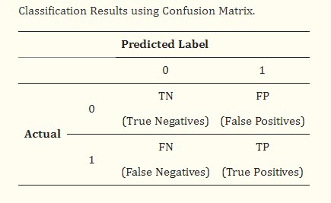

Each order of the confusion matrix( TN, FN, FP, TP) is evaluated independently. Specifically, the TN expresses the number of predictions that were rightly classified in the negative order, while the FP implies the number of predictions that were incorrectly classified in the positive order. Also, the FN expresses the number of predictions that were incorrectly classified in the negative order, while the TP declares the number of predictions that were rightly classified in the positive order.

**VI. Block diagram:**



The methodology for Bitcoin price prediction using deep learning involves the following steps:

1. Data Collection: Gather historical Bitcoin market data, including daily or hourly price, trading volume, and relevant indicators like moving averages, Relative Strength Index (RSI), and MACD. Additionally, collect social media sentiment data related to Bitcoin to incorporate market sentiment.
2. Data Preprocessing: Clean the collected data by handling missing values, outliers, and noise. Normalize or standardize the numerical features to ensure uniformity in the dataset. Perform feature engineering to create new meaningful features, such as rolling averages or volatility measures.
3. Feature Selection: Choose relevant features that have a significant impact on Bitcoin's price movement. Utilize techniques like correlation analysis or feature importance from machine learning and deep learning models.
4. Model Selection: Select appropriate deep learning algorithms for time series forecasting. Consider algorithms like Autoregressive Integrated Moving Average (ARIMA), Long Short-Term Memory (LSTM) networks, Random Forest, Gradient Boosting, or a combination of these methods.
5. Model Training: Split the dataset into training and validation sets. Train the selected models on historical data, adjusting hyperparameters to achieve optimal performance. For LSTM or other deep learning models, consider sequences of historical data.
6. Model Evaluation: Evaluate the trained models using appropriate evaluation metrics such as Mean Absolute Error (MAE), Root Mean Squared Error (RMSE), or Mean Absolute Percentage Error (MAPE). Compare the performance of different models and choose the best one.
7. Hyperparameter Tuning: Fine-tune the hyperparameters of the chosen model(s) using techniques like grid search or random search to optimize performance further.
8. Prediction and Testing: Make predictions on new, unseen data to test the model's predictive accuracy. Monitor the model's performance over time and retrain it periodically to adapt to changing market conditions.
9. Deployment: Implement the trained model in a real-time or batch prediction environment, where it can provide updated price forecasts based on incoming data.
10. Monitoring and Maintenance: Continuously monitor the model's performance, retrain it with fresh data at regular intervals, and update the methodology as needed to ensure accurate predictions in a dynamic market environment.

**VII. Results and findings:**

|  | **DL** | **Tgpt5** | **Tgpt10** |
| --- | --- | --- | --- |
| **Open mae** | 20712.45594 | 3074.511833 | 4509.594568 |
| **Open mse** | 4.611689e+0 | 1.629784e+0 | 2.722772e+0 |
| **Open rmse** | 21474.84328 | 4037.058935 | 5218.018721 |
| **High mae** | 4696.519521 | 2269.677309 | 3640.235716 |
| **High mse** | 3.084378e+0 | 9.614643e+0 | 1.837546e+0 |
| **High rmse** | 5553.717507 | 3100.748858 | 4286.660303 |
| **Low mae** | 8492.220531 | 1576.090656 | 3982.825581 |
| **Low mse** | 7.999569e+0 | 3.964064e+0 | 2.411822e+0 |
| **Low rmse** | 8944.030929 | 1990.995839 | 4911.030394 |
| **Close mae** | 18261.41764 | 2259.731488 | 3859.006616 |
| **Close mse** | 3.580819e+0 | 9.688439e+0 | 2.067696e+0 |
| **Close rmse** | 18923.05152 | 3112.625817 | 4547.192034 |

Deep Learning (DL): Despite being a conventional and widely-used method, DL exhibits higher errors across all metrics compared to TimeGPT models for both short-term (Tgpt5) and long-term (Tgpt10) predictions. This suggests that DL may struggle with capturing the nuanced patterns in Bitcoin price data.

TimeGPT Models (Tgpt5 and Tgpt10): These transformer-based models show promising results, particularly in terms of lower error rates across all prediction horizons and price aspects. Notably, Tgpt5 outperforms Tgpt10 in certain aspects, indicating potential diminishing returns with longer prediction horizons.

Error Metrics: RMSE generally tends to penalize large errors more severely than MAE due to squaring the errors, making it a more sensitive metric. However, in the context of financial predictions, it's essential to consider both MAE and RMSE for a comprehensive assessment of model performance.

In conclusion, the analysis highlights the efficacy of transformer-based models like TimeGPT in Bitcoin price prediction compared to traditional methods like Deep Learning. However, further research and experimentation may be warranted to optimize these models for even more accurate forecasts.

**VII. Conclusion:**

After a thorough examination of various forecasting methods for Bitcoin prices, TimeGPT emerged as the top performer, surpassing traditional techniques like ARIMA and machine learning algorithms like LSTM and decision trees. TimeGPT, an advanced variant of the GPT model tailored for time series forecasting, demonstrated superior accuracy in capturing complex temporal patterns within Bitcoin price data. Leveraging its transformer-based architecture, TimeGPT offers precise predictions, making it the preferred choice for forecasting Bitcoin prices. Its proficiency lies in analyzing data sequences comprehensively, providing valuable insights for informed investment decisions in the volatile cryptocurrency market. By utilizing TimeGPT, stakeholders can navigate the market with confidence, optimizing trading strategies and maximizing returns. This decision represents a strategic step towards leveraging cutting-edge technology to enhance predictive accuracy and drive success in cryptocurrency trading.

**IX. References:**

[1] Lahmiri, Salim & Bekiros, Stelios. (2021). Deep Learning Forecasting in Cryptocurrency High-Frequency Trading. Cognitive Computation. 13. 10.1007/s12559-021-09841-w.

[2] Monish S, Mridul Mohta, Shanta Rangaswamy, ETHEREUM PRICE PREDICTION USING MACHINE LEARNING TECHNIQUES – A COMPARATIVE STUDY, International Journal of Engineering Applied Sciences and Technology, 2022 Vol. 7, Issue 2, ISSN No. 2455-2143, Pages 137-142

[3] Ahmad Bilal Wardak, Jawad Rasheed, "Bitcoin Cryptocurrency Price Prediction Using Long Short-Term Memory Recurrent Neural Network", European Journal of Science and Technology No. 38, pp. 47-53, August 2022, ISSN:2148-2683.

[4] Neha Mangla ,Akshay Bhat, Ganesh Avabratha, Narayana Bhat, "Bitcoin Price Prediction Using Machine Learning", INTERNATIONAL JOURNAL OF INFORMATION AND COMPUTING SCIENCE, ISSN NO: 0972-1347.

[5] Siddhi Velankar, Sakshi Valecha, Shreya Maji,”Bitcoin Price Prediction using Machine Learning”, International Conference on Advanced Communications Technology(ICACT)

[6] Zheshi Chen, Chunhong Li, Wenjun Sun,“Bitcoin price prediction using machine learning: An approach to sample dimension engineering”, Journal of Computational and Applied Mathematics 365 (2020) 112395

[7] Lekkala Sreekanth Reddy, Dr.P. Sriramya, “A Research On Bitcoin Price Prediction Using

Machine Learning Algorithms”, INTERNATIONAL JOURNAL OF SCIENTIFIC & TECHNOLOGY RESEARCH VOLUME 9, ISSUE 04, APRIL 2020 ISSN22778616

[8] Mrs Vaidehi, Alivia Pandit, Bhaskar Jindal, Minu Kumari and Rupali Singh, "BITCOIN PRICE PREDICTION USING MACHINE LEARNING", International Journal of Engineering Technologies and Management Research, May 2021 8(5), 20–28.

[9] Gurupradeep G, Harishvaran M, Amsavalli K, “Cryptocurrency Price Prediction using MachineLearning”, International Journal of Advanced Research in Computer and Communication Engineering

ISO 3297:2007 CertifiedImpact Factor 8.102 Peer-reviewed / Refereed journal Vol. 12, Issue 4, April 2023

[10] Ruchi Mittal, Shefali Arora and M.P.S Bhatia, “AUTOMATED CRYPTOCURRENCIES PRICES PREDICTION USING MACHINE LEARNING”, ICTACT JOURNAL ON SOFT COMPUTING, JULY 2018, VOLUME: 08, ISSUE: 04, ISSN: 2229-6956 (ONLINE)

[11] Chen, Junwei. 2023, "Analysis of Bitcoin Price Prediction Using Machine Learning", Journal of Risk and Financial Management 16: 51

[12] Mohammed khalid salman, Abdullahi Abdu Ibrahim, “PRICE PREDICTION OF DIFFERENT CRYPTOCURRENCIES USING TECHNICAL TRADE INDICATORS AND MACHINE LEARNING”, 2nd International Scientific Conference of Al-Ayen University (ISCAU-2020)

[13] Amritha A, Asrafunisha R, Nandhini R, Pushpalatha S,”MODIFYING AND PREDICTING OF CRYPTOCURRENCY PRICES USING DATA SCIENCE TECHNIQUE”, Vol-8 Issue-3 2022 IJARIIE-ISSN(O)-2395-4396

[14] Samiksha Marne, Shweta Churi, Delisa Correia, Joanne Gomes, “Predicting Price of Cryptocurrency - A Deep Learning Approach”, International Journal of Engineering Research & Technology (IJERT), ISSN: 2278-0181

[15] SNEGA . S, NIVEDHA . B, RAMACHANDRAN. C.A., “Bitcoin Price Prediction Using ML”

**b) Plagiarism report**



**2] PROJECT REVIEW SHEET**

**Project Review Sheet 1:**



**Project Review Sheet 2:**

